***Program1:-Write a program in c language for addition , subtraction, multiplication, division of two number?***

#include<stdio.h>

int main(){

    float a, b, add, multi, sub, divi;

    printf("Enter first number = \n");

    scanf("%f", &a);

    printf("Enter second number = \n");

    scanf("%f", &b);

    add = a + b;

    sub = a - b;

    multi = a * b;

    divi = a / b;

    printf("add= %0.1f\n"  ,add);

    printf("sub = %0.1f \n" ,sub);

    printf("multi = %0.1f \n" ,multi);

    printf("divide = %0.1f \n" ,divi);

    return 0;

}

Test Data-

Output:

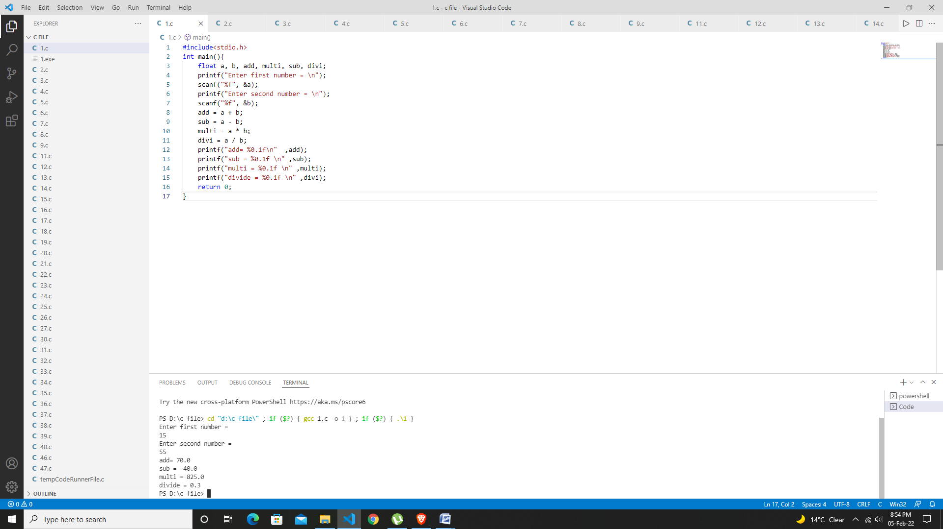

***­­Program2:- calculate simple interest of a set of values representing Principle amount ,no of years and rate of interest.***

#include<stdio.h>

int main(){

    float principal, years ,rate;

    float simple_interest;

    printf("Enter Principle Amount = \n");

    scanf("%f",&principal);

    printf("Enter Rate = \n");

    scanf("%f",&rate);

    printf("Enter No Of Years = \n");

    scanf("%f",&years);

    simple_interest = (principal*years*rate)/100;

    printf(" This Is Simple Interest Of Amount = %0.1f",simple_interest);

    return 0;

}

Test Data-

Output:

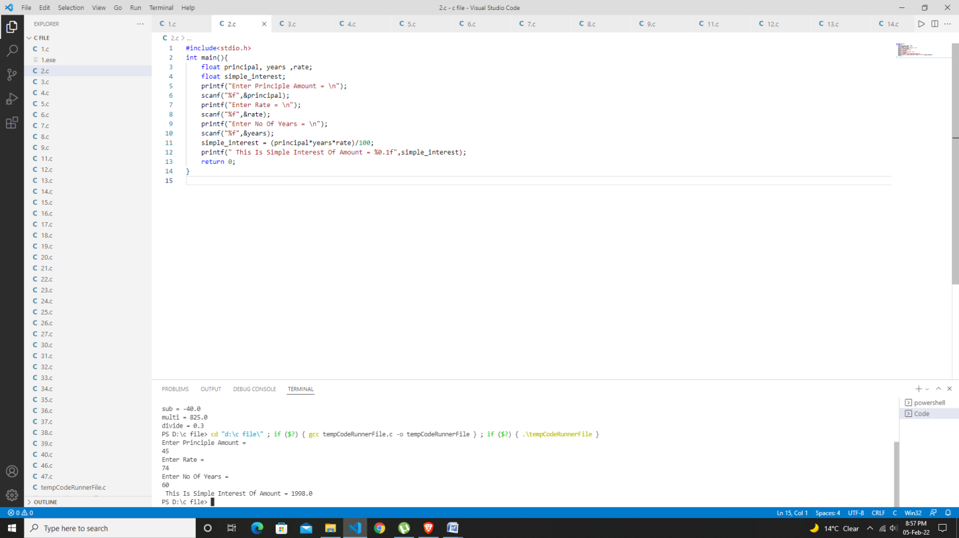

***Program3:-Ramesh’s basic salary is input through the keyboard . his deacnessallowance is 40% of basic salary and house rent allowance is 20% of basic salary write a program to find his gross salary.***

#include<stdio.h>

int main(){

    int salary, house_rent, dra, gross_salary;

    printf("Enter Your Salary = \n");

    scanf("%d",&salary);

    house_rent = (salary*20)/100;

    dra= (salary*40)/100;

    gross_salary = house_rent + dra + salary;

    printf("This Is Net Salary %d ",gross_salary);

    return 0;

}

Test Data-

Output

: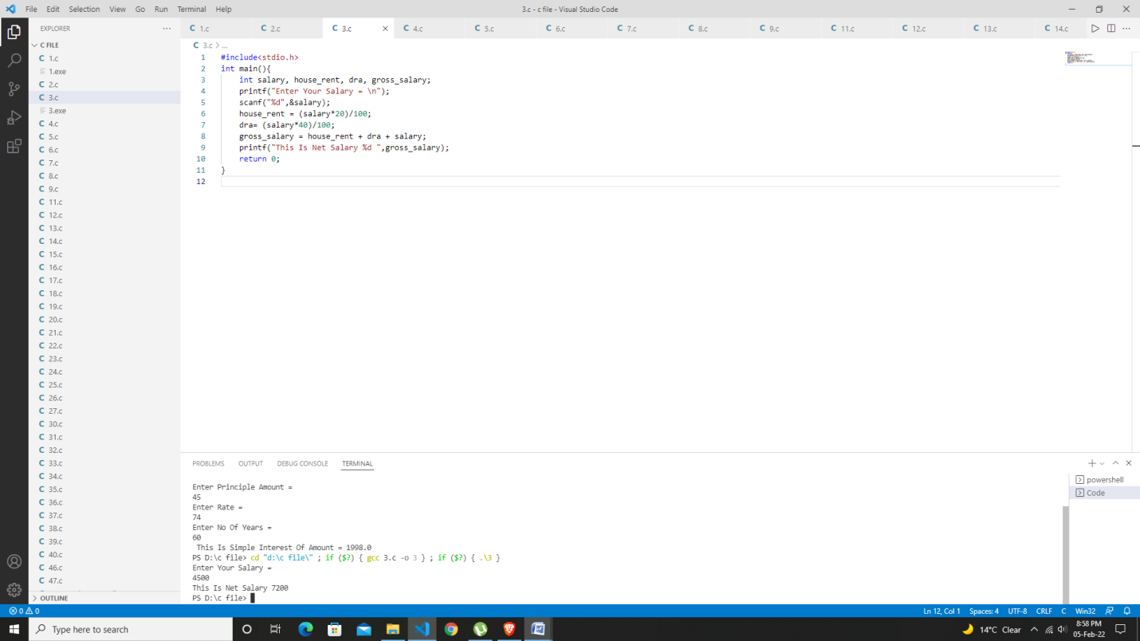

***Program4:- the length & breath of a Rectangle and radius of a circle are input through the keyboard . write a program to calculate the Area and perimeter of rectangle and the area & Circumference of the circle.***

#include<stdio.h>

int main(){

    float length, breadth ,radius , area_rectangle, perimeter;

    float pi=3.14 ,area_Circle ,circumfrence_circle ;

    printf("Enter Length of Rectangle =  \n");

    scanf("%f",&length);

    printf("Enter Breath of Rectangle =  \n");

    scanf("%f",&breadth);

    printf("Enter Radius of circle =  ");

    scanf("%f",&radius);

    area_rectangle = length*breadth ;

    perimeter = 2*(length+breadth);

    area_Circle = pi*radius*radius;

    circumfrence_circle = 2*pi*radius;

    printf("This is Area Of Rectangle is = %0.1f \n", area_rectangle);

    printf("This is Perimeter Of Rectangle is = %0.1f \n",perimeter );

    printf("This is Area Of Circle  is = %0.1f \n", area_Circle );

    printf("This is Circumfrence Of Circle  is = %0.1f \n", circumfrence_circle);

    return 0;

    }

Test Data-

Output:

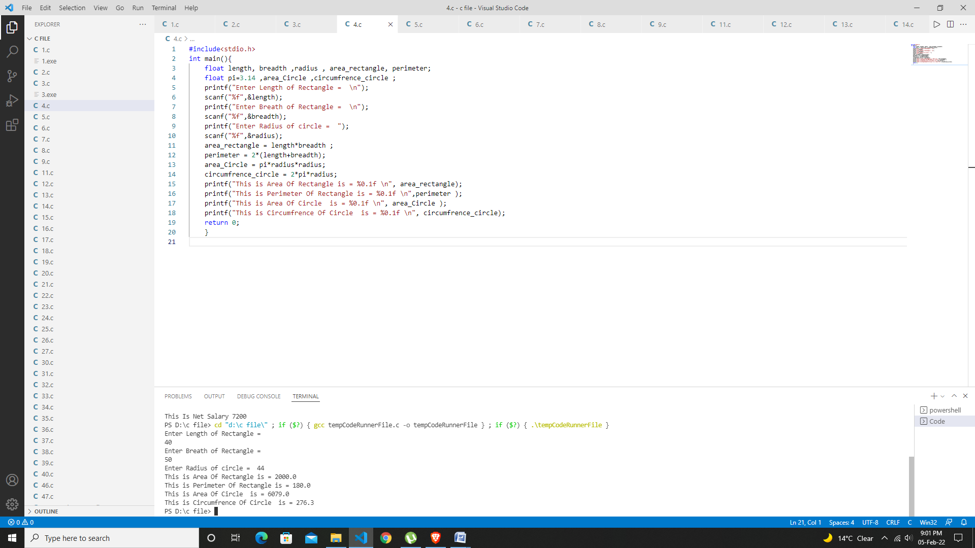

***Program5:- write a program to convert celsius to Fahrenheit*** .

#include<stdio.h>

int main(){

    float far, celsius, cel ;

    // for convert celsius to fahrenheit ***

    printf("Enter Temprature In Celsius = \n");

    scanf("%f",&celsius);

    far= (celsius * 9/5) + 32 ;

    printf("Temprature In Celsius To Fahrenheit Is %0.2f ",far);

      //for convert fahrenheit to celsius ***

    // printf("Enter your fahrenheit = ");

    // scanf("%f",&far);

    // cel =  (far-32)*5/9;

    // printf("convert  fahrenheit to celsius %0.2f ",cel);

    return 0;

}

Test Data-

Output:

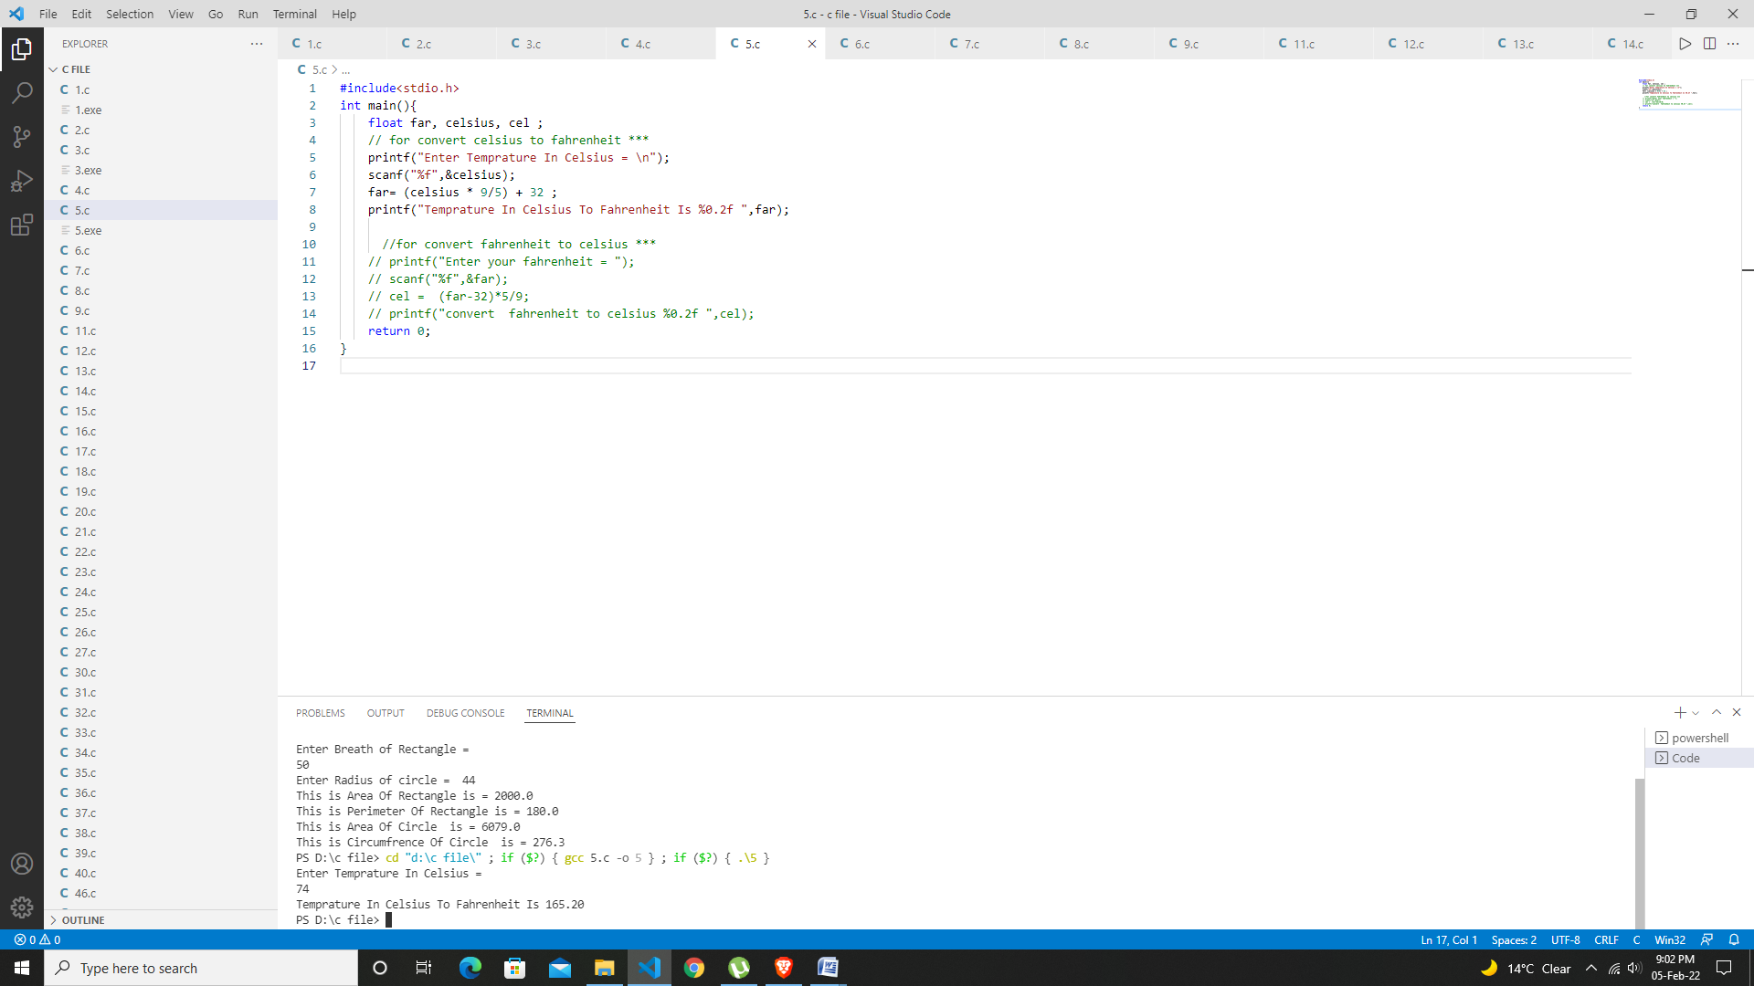

***Program6:-the distance between the two cities (in km) is input through the keyboard. Write a program to convert and print the distance in meters , feet , inches and centimeters.***

#include<stdio.h>

     //program6 conversion ***

int main(){

    float km, m, cm, feet, inches;

    printf("Enter Distance Between Two Cities (in km) = \n");

    scanf("%f",&km);

    m = 1000*km;

    cm = 1000*100*km;

    feet = 3280.84*km;

    inches = 39370.1*km;

    printf("Distance Between Two Cities In Meters= %.2f\n",m);

    printf("Distance Between Two Cities In Feet= %.2f\n",feet);

    printf("Distance Between Two Cities In Centimeters= %.2f\n",cm);

    printf("Distance Between Two Cities In Inches = %.2f\n",inches);

    return 0;

}

Test Data-

Output:

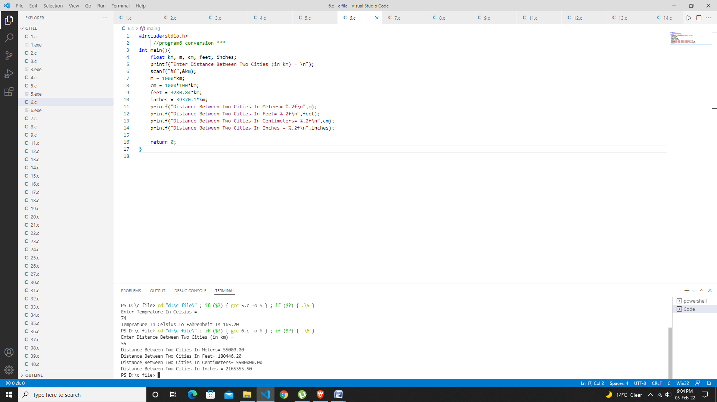

***Program7:-write a program to find the greatest integer among 3 number given by user .***

#include<stdio.h>

int main(){

    int a, b, c;

    printf("Enter Three Number\n");

    scanf("%d %d %d",&a, &b, &c);

    if (a>=b && a>=c)

    {printf("This n1 is greatest integer =%d",a);  }

    else if (b>=a && b>=c)

    {printf("This n2 is greatest integer =%d",b);}

    else if(c>=b && c>=b)

    {printf("This n3 is greatest integer =%d",c); }

    return 0;

    }

Test Data

Output:

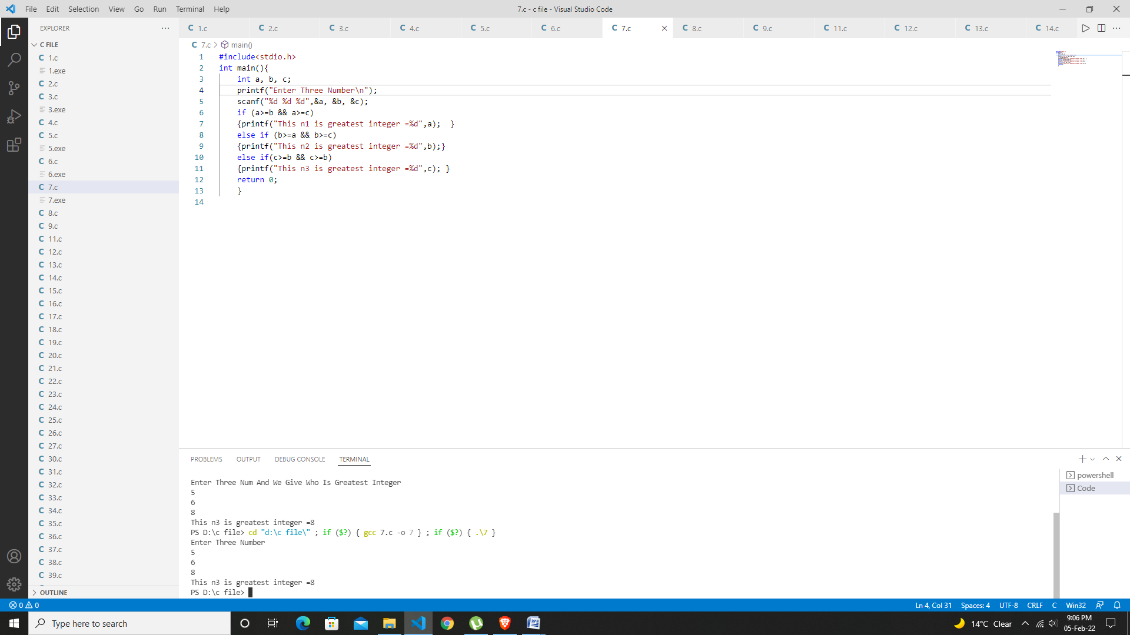

***Program8:- while purchasing a certain item discount of 10% offered. if the quantity purchase more than 1000. if quantity less than 1000 then no discount.***

***And quantity and item input from the user then write a program to calculate the***

***Total expances.***

#include<stdio.h>

 int main(){

     int si, n, Price , net_Price;

     printf("Enter Your Book Quantity = \n");

     scanf("%d",&n);

     printf("Enter Your Book Price = \n");

     scanf("%d",&Price);

     net_Price = n*Price;

     if (n>=1000){

        // si=(Price*10)/100;

        // net_Price = (Price-si)*n;

        // Book_discount of 10%

        int amount=(net_Price*10)/100 ;

        int total=net_Price-amount;

        printf("Book Discount Is (10%d).\n (Book If You Buy >1000) \n");

        printf("This Is Net Amount Of Purchase Book %d",total); }

     else if (n<=1000)

     {printf("This Is Net Amount Of Purchase Book %d",net_Price);}

     else{printf("You Purchase Nothing"); }

     return 0;

 }

Test Data

Output:

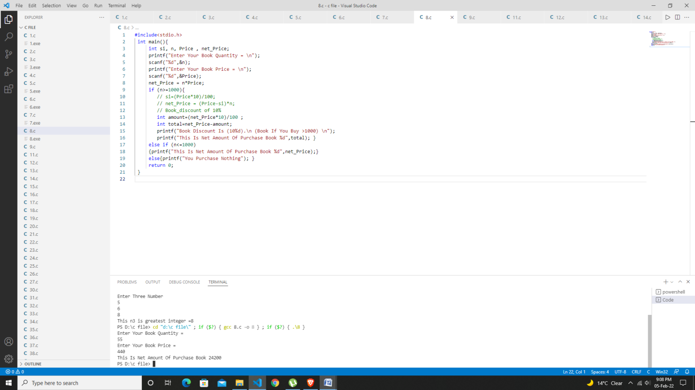

***Program9,10:- write a program input two number from the user and with two location c & d write a program to interchange the contents of c & d .***

#include<stdio.h>

int main(){

    int c, d, temp;

    printf(" We Are Doing Swapping Of A Given Number \n");

    printf("Enter First Num = \n");

    scanf("%d",&c);

    printf("Enter Second Num = \n");

    scanf("%d",&d);

    //without taking any variable ***

    // c=c+d;

    // d=c-d;

    // c=c-d;

    // with the help of third variable ***

      temp=c;

      c=d;

      d=temp;

    printf("The Value Of Num After Swapping c = %d \n",c);

    printf("The Value Of Num After Swapping d = %d \n",d);

    return 0;}

Test Data

Output:

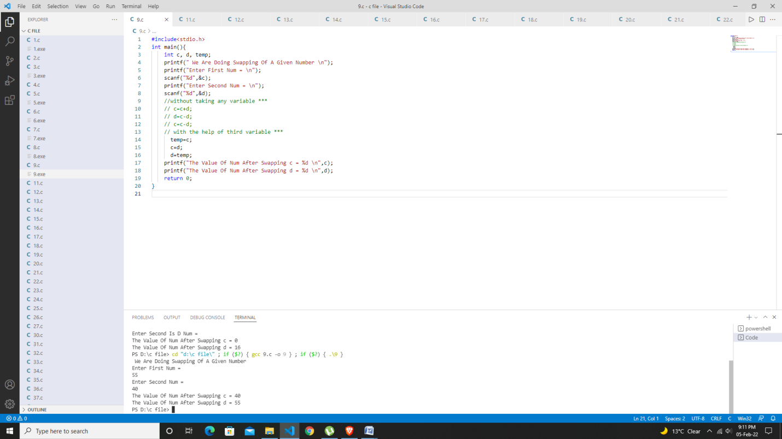

***Program11:- if five digit number input from user . and write a program to calculate the Sum of it’s self .***

#include<stdio.h>

int main(){

    int num, sum;

    printf("Enter Five Numbers = \n");

    scanf("%d",&num);

sum=(num%10) +(num/10)%10 +(num/100)%10 +(num/1000)%10 +(num/10000)%10;

    printf("Sum %d",sum);

    return 0;

}

Test Data

Output:

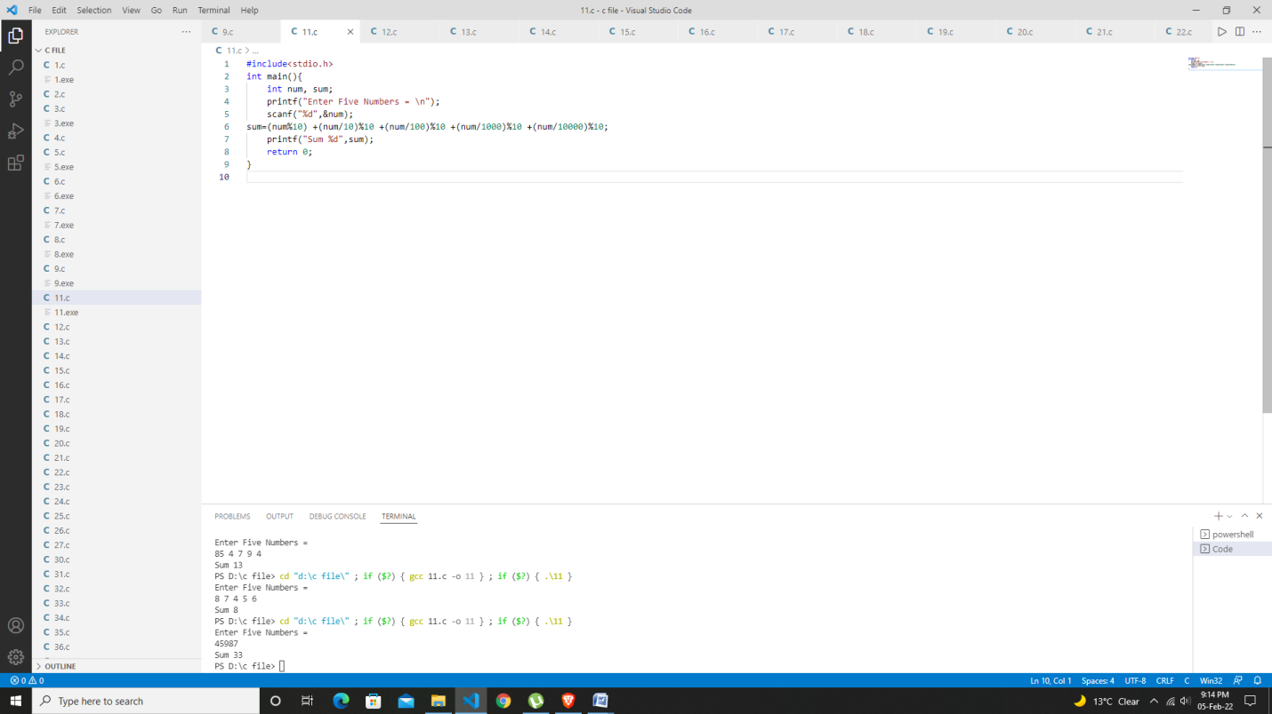

***Program12:- if the five number input to keyboard. Write a program to display the given five digit number in reverse order.***

#include<stdio.h>

int main(){

    int n, a, b, c, d, e;

    printf("This Program Give Reverse Of Five Digit Number \n");

    printf("Enter Five Digit Num =  \n");

    scanf("%d",&n);

    a=n%10;

    b=(n/10)%10;

    c=(n/100)%10;

    d=(n/1000)%10;

    e= n/10000;

    printf("This Is Reverse Number Of Given By User = %d %d %d %d %d",a,b,c,d,e);

    return 0;

}

Test Data

Output:

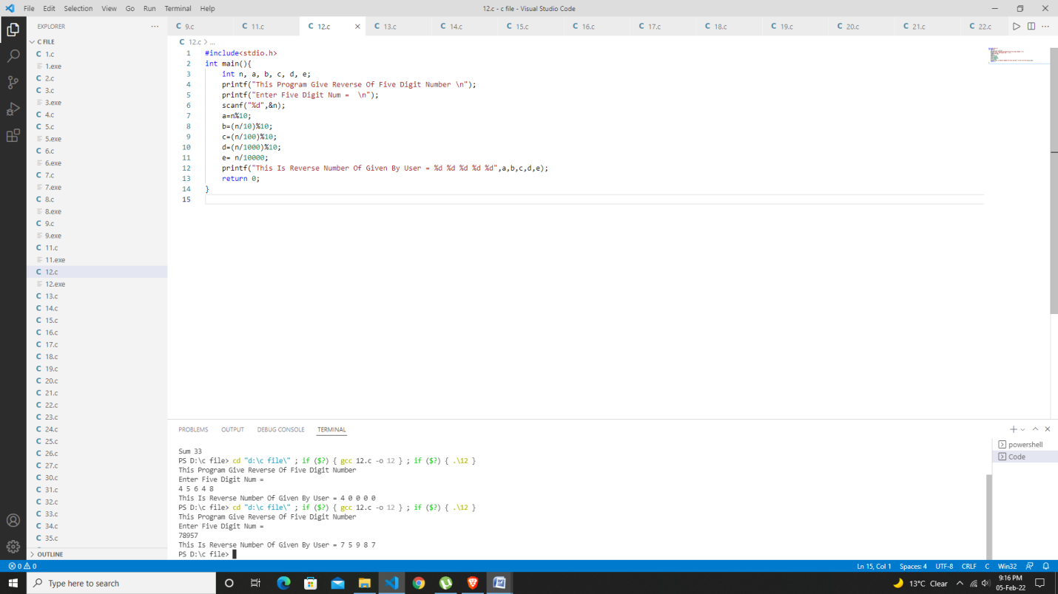

***Program13:- If an employee basic salary is less than 1500 nri then HRA will be 10% of basic salary and DA 90% nri of basic salary .if the basic salary is either equal to or above 1500 nri,then HRA is 500nri DA will be 98% of basic salary. If the employee enter salary through the keyboard ,write a program to find his gross salary .***

#include<stdio.h>

int main(){

    int bs, HRA, DA, gross_salary;

    printf("Enter Your Basic Salary \n");

    scanf("%d",&bs);

    if (bs<1500){

        HRA=(bs*10)/100;

        DA=(bs*90)/100;

    }

    else if (bs>=1500){

        HRA=500;

        DA=(bs*98)/100;

    }

    gross_salary = bs+HRA+DA;

    printf("This Is Our Gross Salary Is = %d",gross_salary);

    return 0;

}

Test Data

Output:

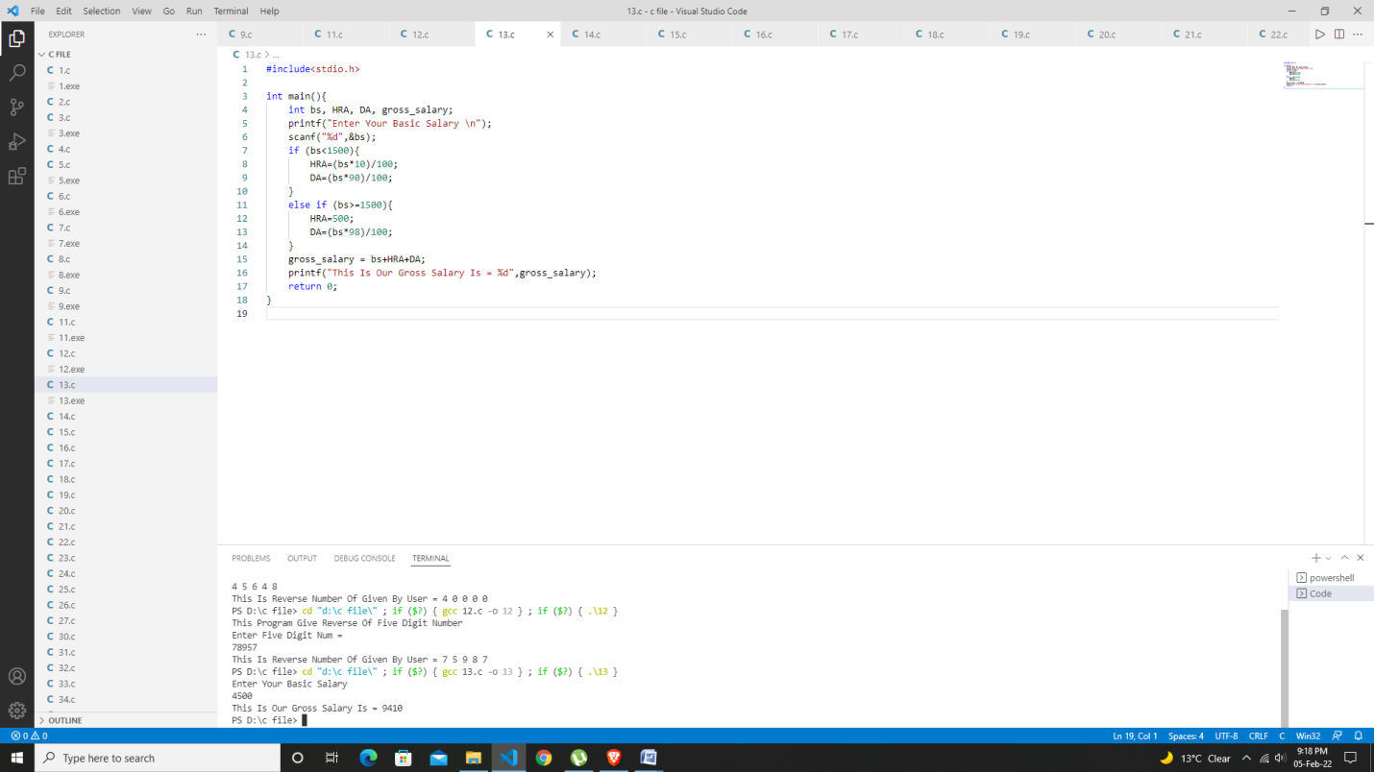

***Program14:-write a program to check if a given number is odd or even.***

#include<stdio.h>

int main(){

    int num;

    printf("This Is Program Give Your Entered Num Is Odd Or Even \n ");

    printf("Enter Your Num = \n");

    scanf("%d", &num);

    if (num%2==0){

        printf("This Is Even Num ");

    }

    else{

        printf("This Is Odd Num ");

    }

    return 0;}

Test Data

Output:

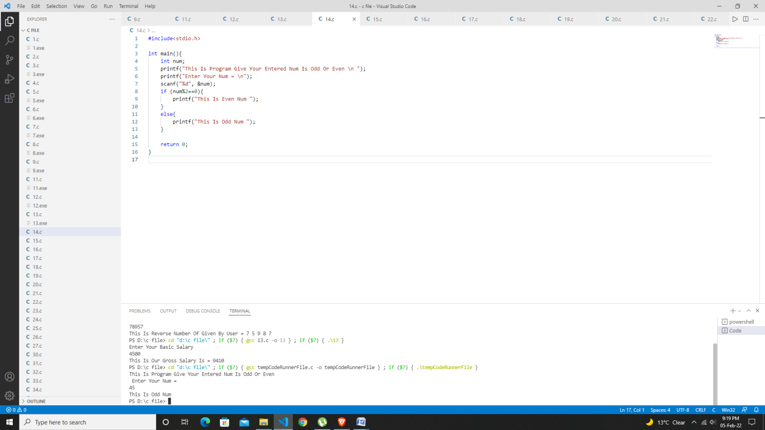

***Program15:-Wap to check if a given number is prime or not.***

#include<stdio.h>

int main(){

    int num, i;

    printf("Enter Your Number \n");

    scanf("%d",&num);

    for (i=2 ; i<=num-1; i++){

        if (num%i==0){

            printf("Not A Prime Number");

            break;

        }

    }

    if (num==i){

        printf("Prime number");

    }

    return 0;

}

Test Data

Output:

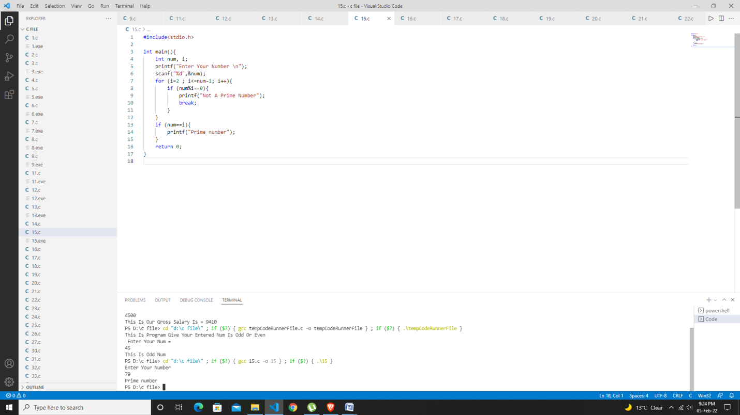

***Program16:- Program to check whether the given number is even or odd using conditional operator***

#include<stdio.h>

int main(){

    int num;

    printf("This Is Program Give Your Entered Num Is Odd Or Even \n");

    printf("Enter Your Num = \n");

    scanf("%d", &num);

    (num%2==0)?printf("Your Num Is Even %d",num):printf("Your Num Is Odd %d",num);

    return 0;

}

Test Data

Output:

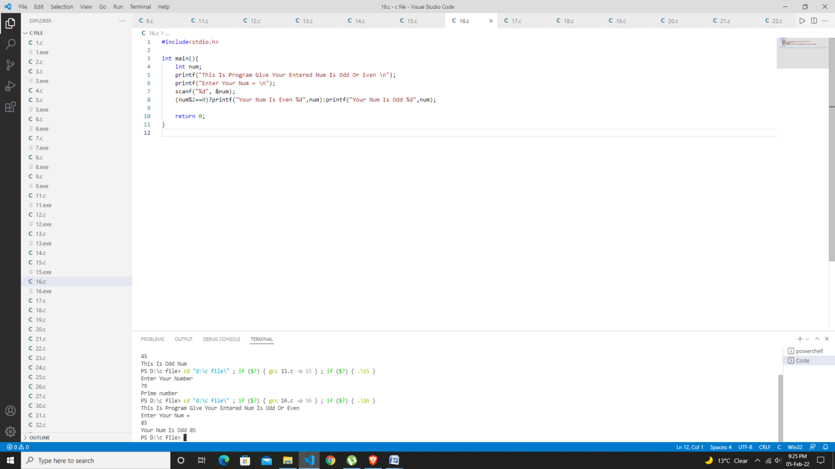

***Program17:-write a program to find the average of 6 subjects and display the result as follows.***

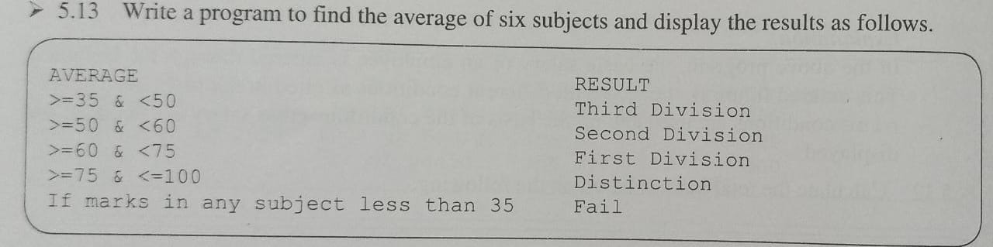

#include<stdio.h>

int main(){

    int M1, M2, M3, M4, M5, M6, avg;

    printf("Enter You Six Subject Marks = \n");

    scanf("%d %d %d %d %d %d",&M1,&M2,&M3,&M4,&M5,&M6);

    avg =(M1+M2+M3+M4+M5+M6)/6;

    printf("Average Of Your Marks %d\n",avg);

    if ((M1<35) || (M2<35) || (M3<35) || (M4<35) || (M5<35) || (M6<35) ){

        printf(" You Are Fail \n");

    }

    else{

    if(50>avg && avg>=35){ printf("Result : Third Division \n");   }

    else if (60>avg && avg>=50){  printf("Result : Second Division \n");  }

    else if (75>avg && avg>=60){    printf("Result : First Division \n");  }

    else if (100>avg && avg>=75){   printf("Result : Distinction Division \n");   }

    }

    return 0;

}

Test Data

Output:

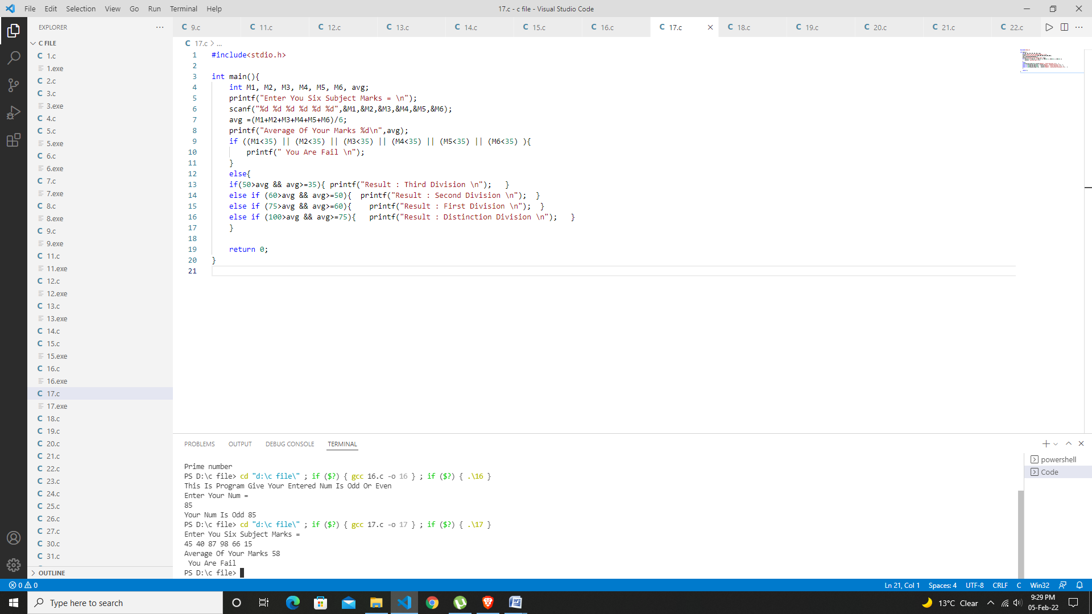

***Program18:-write a program in C to print a table of any number using for loop.***

#include<stdio.h>

int main(){

    int num;

        printf("Enter Your Num Want To Print Table =  \n");

        scanf("%d",&num);

        printf("Print Table \n");

        for (int i = 1; i<=10; i++)

        {

           printf("%d*%d = %d\n",num, i, (num * i));

        }

    return 0;

}

Test Data

Output: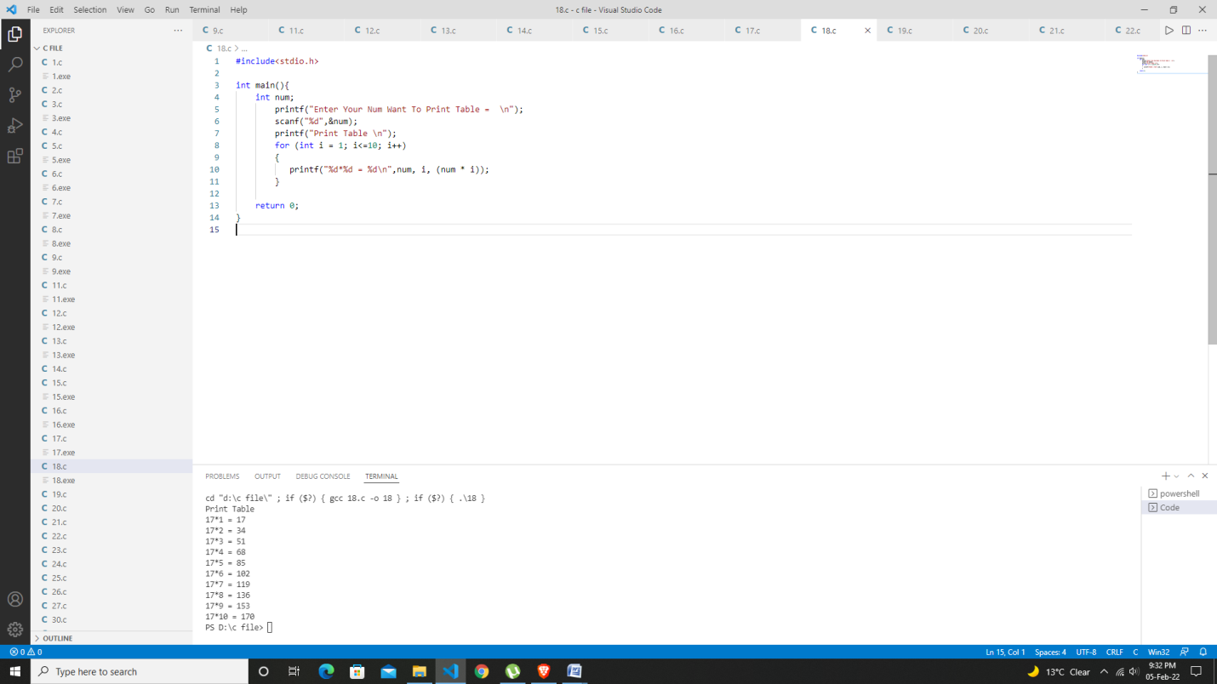

***Program19:- write program in C to print table of any number using while loop.***

#include<stdio.h>

int main(){

    int num, i=1;

        printf("Enter Your Num Want To Print Table Num =  \n");

        scanf("%d",&num);

        printf("Print Table \n");

        while(i<=10){

            printf("%d x %d = %d \n",num, i, num*i);

            i++;

        }

    return 0;

}

Test Data

Output:

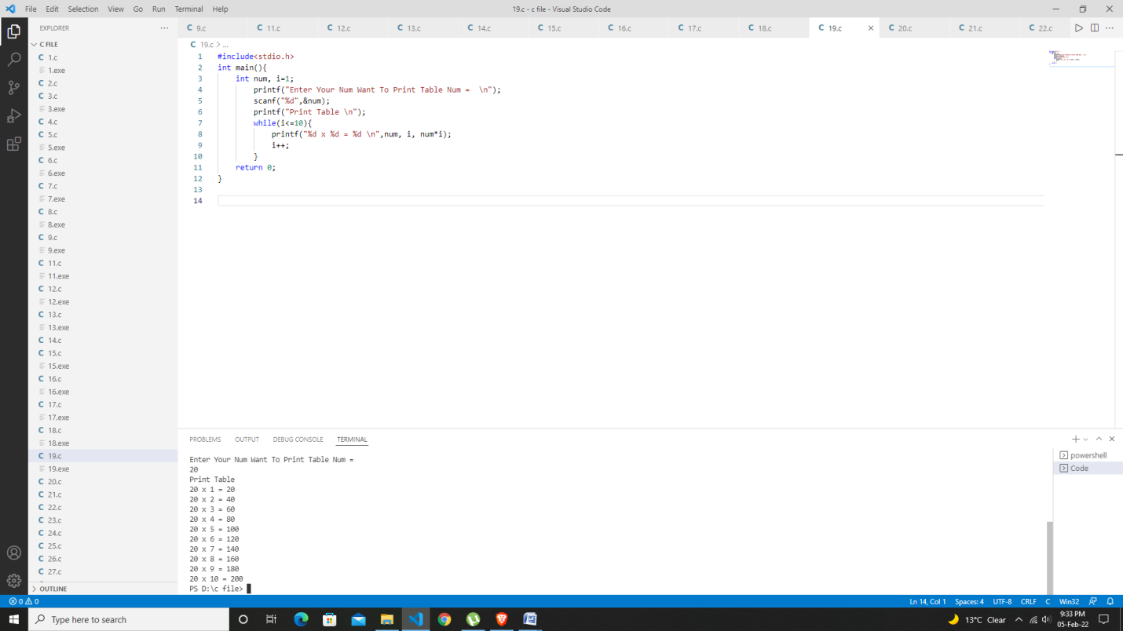

***Program20:-write a program to find the factorial value of any number entered through the keyboard***

#include<stdio.h>

int main(){

    int num, fact=1;

    printf("Enter Your Number \n");

    scanf("%d",&num);

    for (int i = 1; i<= num; i++)

{

        fact=fact*i;

    }

    printf("Your Number %d And Factorial %d", num, fact);

    return 0;

}

Test Data

Output:

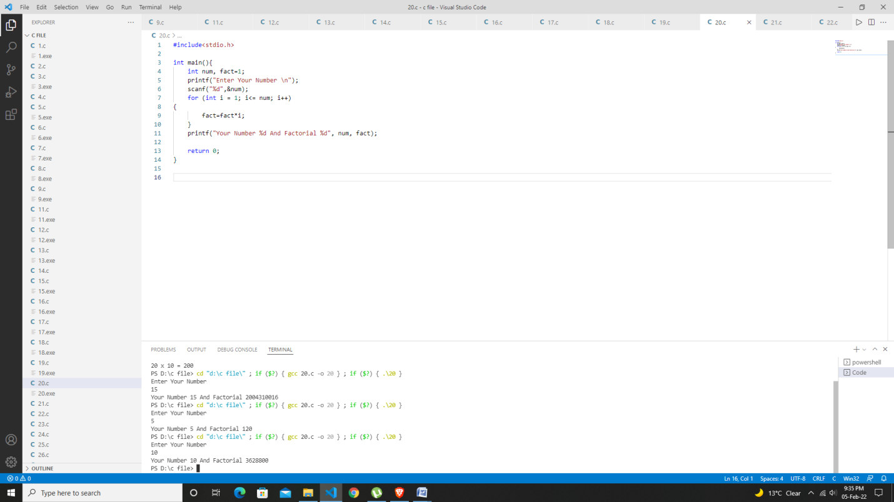

***Program21:-write a program to calculate the salary of three persons the given data basic salary is input through keyboard***

***Hra = bs of 90%***

***Da = 10% of bs***

***Calculate gross salary***

#include<stdio.h>

int main(){

    int i, bs, hra, Da, Gs;

    for ( i=1 ; i<= 3; i++)

    {

        printf("Enter Your Basic Salary =  \n");

        scanf("%d",&bs);

        hra=(bs*90)/100;

        Da=(bs*10)/100;

        Gs=bs+hra+Da;

        printf("\n Salary Is = %d\n",Gs);

    }

    return 0;

}

Test Data

Output:

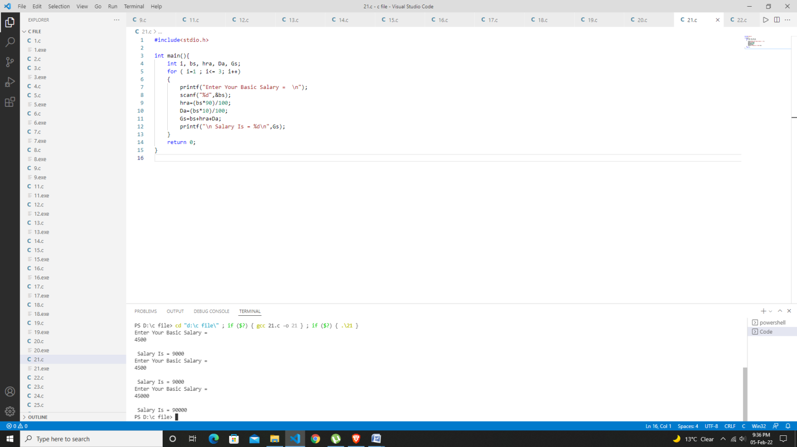

***Program 22: Write a program to print all the odd and even numbers from 1 to 100***

#include <stdio.h>

int main() {

    int counter;

    printf("Even numbers between 1 to 100\n");

    for(counter = 1; counter <= 100; counter++) {

        if(counter%2 == 0) {

            printf("%d ", counter);

        }

    }

    return 0;

}

Output: 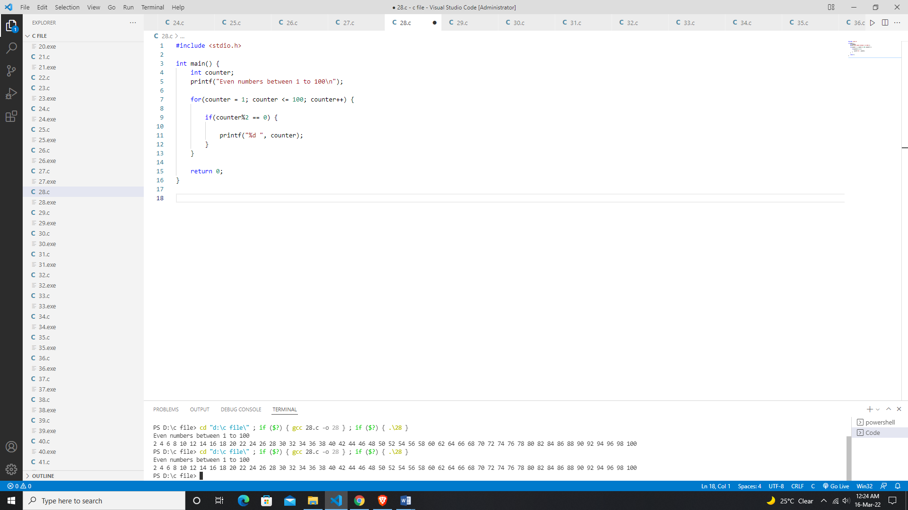

***Program23:-Write a program to print all Armstrong number between 1 and 500***

#include<stdio.h>

int main(){

    int num, rem, sum;

    for (int i = 1; i< 500 ; i++)

    {

        num=i;

        sum=0;

        while (num)

        {

            rem = num %10;

            sum=sum+(rem*rem*rem);

            num=num/10;

        }

        if (i==sum)

        {

            printf("%d Is A Armstrong Number \n",i);

        }

    }

  return 0;}

Test Data

Output:

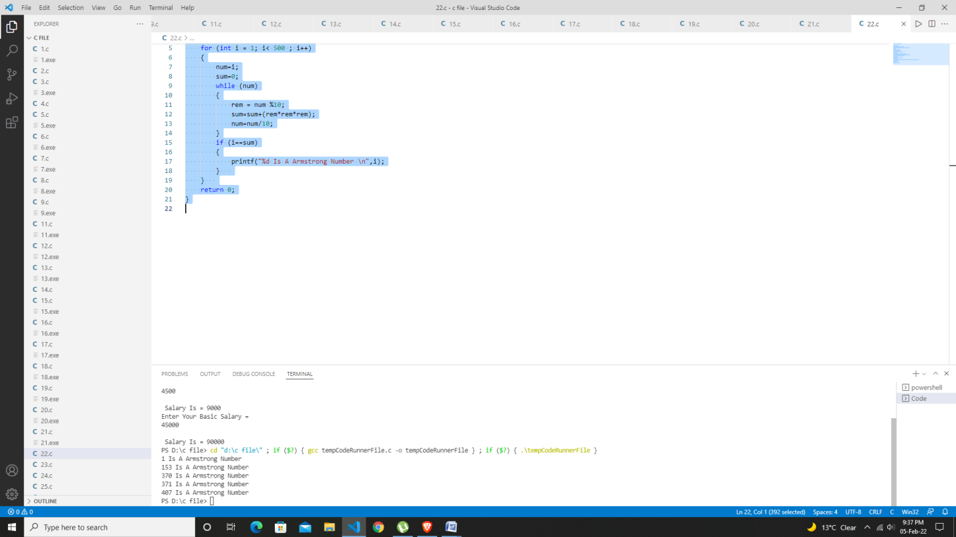

***Program24:two numbers are entered through keyboard write a program to find value of one raised to the power of another.***

#include<stdio.h>

#include<conio.h>

#include<math.h>

int main()

{

    int a, b, c;

    printf("Enter The Value Of A: \n");

    scanf("%d", &a);

    printf("Enter The Value of B: \n");

    scanf("%d", &b);

    c = pow(a,b);

    printf("%d Raised To The Power %d: %d",a,b,c);

}

Test Data

Output:

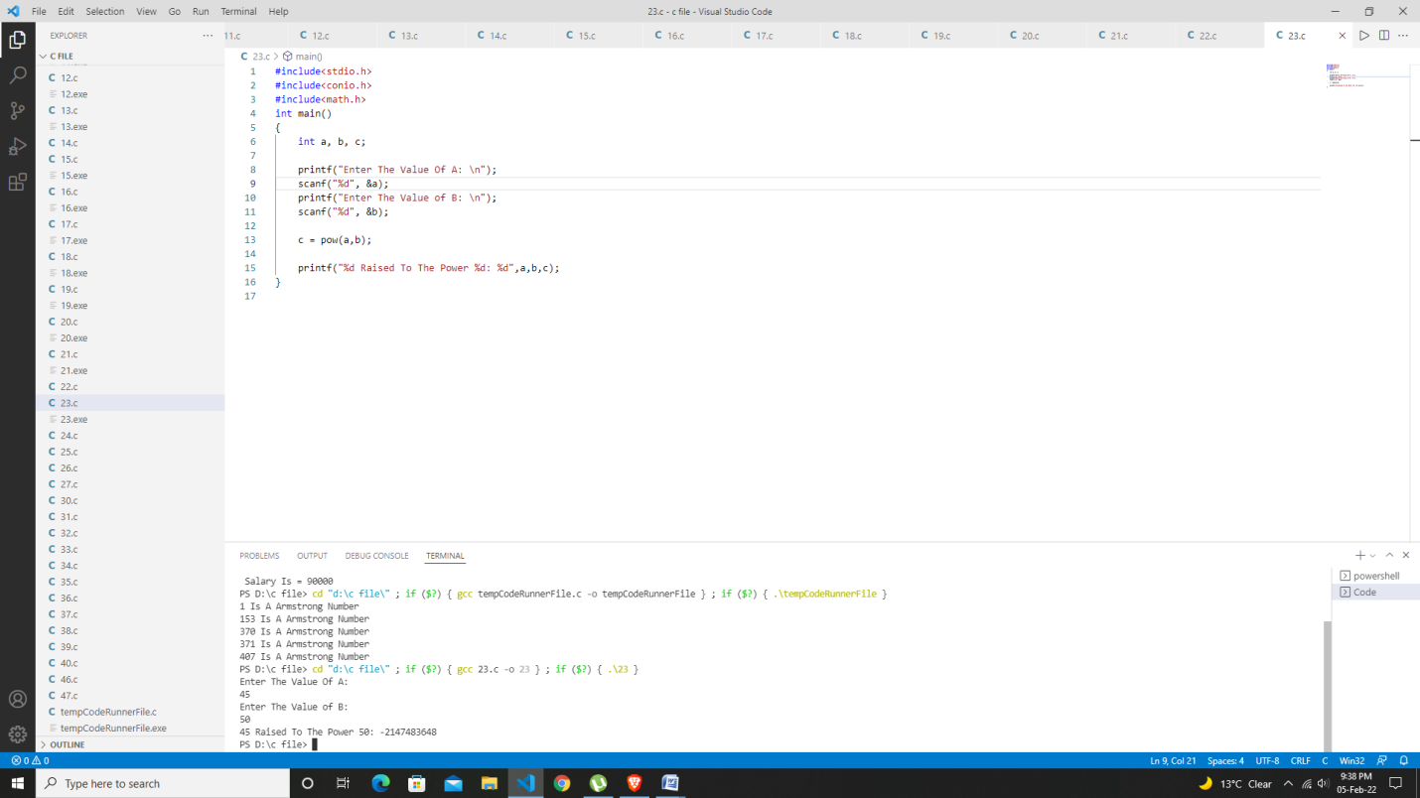

***Program25::-write a program to find if the number is factorial ,Prime or not, odd or even and exit using switch case.***

#include<stdio.h>

int main(){

        int num, choice, fact=1, i, count=0;

        printf("Choice 1 For Factorial \n ");

        printf("Choice 2 For Number Prime Or Not \n");

        printf("Choice 3 For Even Or Not\n");

        printf("Choice 4 For Exit \n");

        printf("Enter Your Choice (1, 2 , 3 , 4 )=  \n");

        scanf("%d",&choice);

        printf("Enter Your Number ");

        scanf("%d",&num);

        switch (choice)

        {

        case 1:

                for ( i = 1; i<=num; i++){

                        fact=fact*i;

                }

                printf("Factorial Of Num=%d Is %d",num,fact);

                break;

        case 2:

                for ( i = 2; i<=num-1; i++){

                        if (num%i==0){     printf("Not A Prime Number");

                                break;

                        }

                }

                if(num==i){      printf("It Is Prime Number");     }

                break;

        case 3:

                if(num%2==0)

                {

                        printf("It Is Even Number");

                }else{

                        printf("It Is Odd Number");

                }

                break;

        case 4:{

                    printf("\nExit");

                }

                break;

        }

        return 0;

        }

Output:

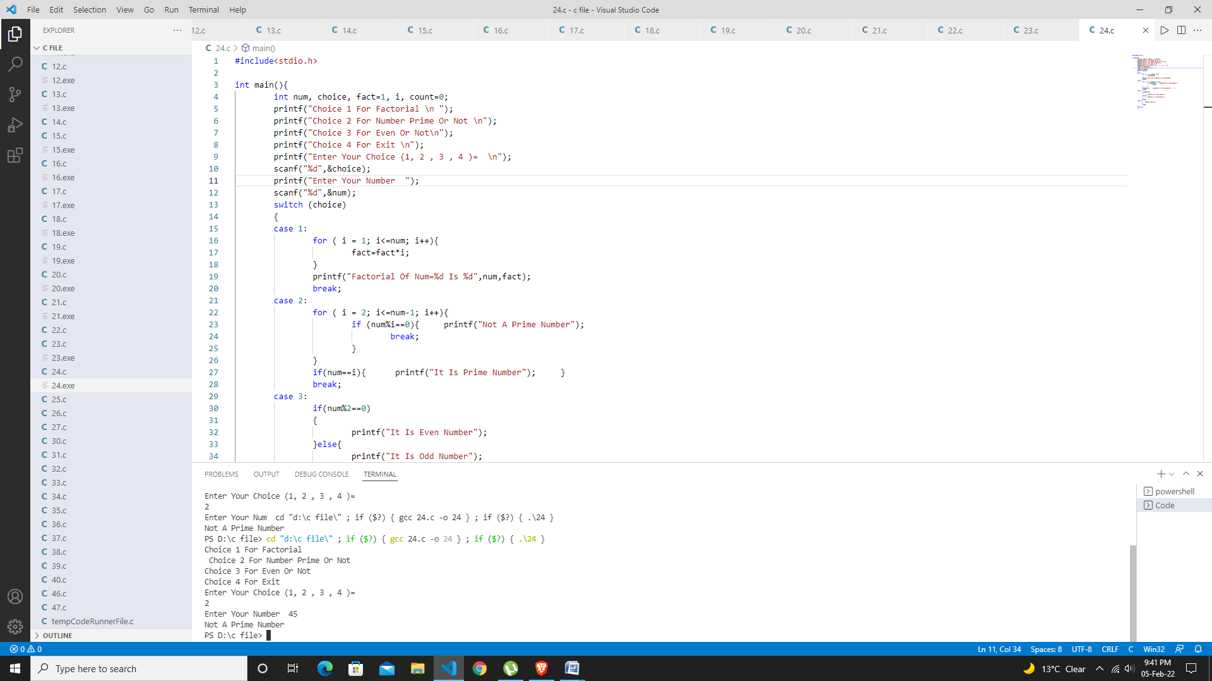

***Program26::- write a menu driven program to construct a Calculator for following arithmetic operations: addition , subtraction ,multiplication , division average and percentage.***

#include<stdio.h>

int main(){

    char op;

    int num1,num2;

    printf("Choose Your Operator = (+ - * /  A P):\n");

    scanf("%c",&op);

    printf("Enter Your Two Number  =\n");

    scanf("%d%d",&num1,&num2);

    switch (op){

        case'+':

            printf("Addition Is %d ",num1+num2);

            break;

        case'-':

            printf("Subtraction Is %d ",num1-num2);

            break;

        case'*':

            printf("Multiply Is %d ",num1*num2);

            break;

        case'/':

            printf("Divide Is %d ",num1/num2);

            break;

        case'A':

            printf("Average Is %d ",(num1+num2)/2);

            break;

        case'P':

            printf("Percentage Is %d ",(num1+num2)/2);

            break;

        default:

            printf("Error Operator Is Not Correct \n");

            break;

        }

    return 0;

}

Test Data

Output:

: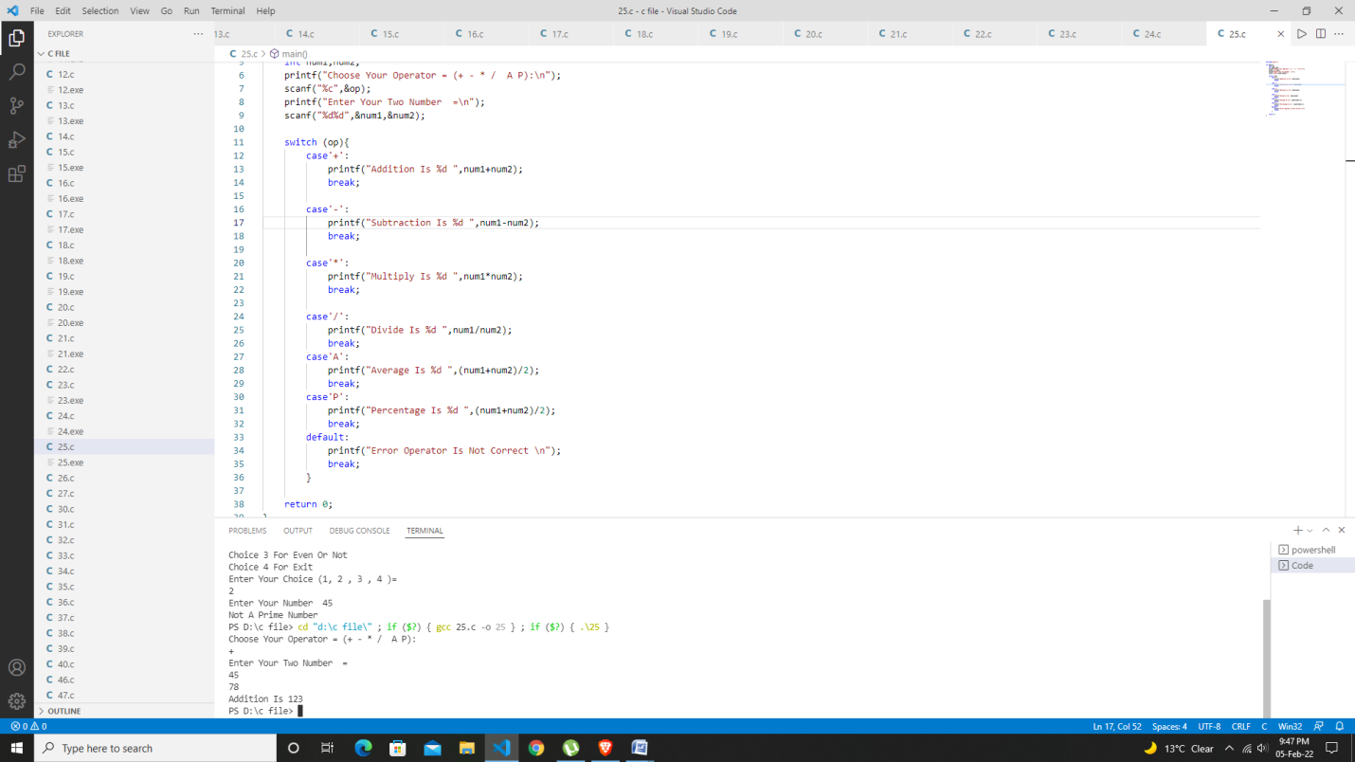

***Program27:-write a menu driven program to perform following Operations:***

***1.print Armstrong number upto N***

***2.Display your Prime number i to N***

***3.Reverse of an Integers***

#include<stdio.h>

int main(){

    int num, i, choice, reverse=0, rem, sum, max;

    printf("Choice 1 For Armstrong Number \n ");

    printf("Choice 2 For Check Prime Or Not \n ");

    printf("Choice 3 For Reverse Your Integer(Num) \n ");

    printf("Enter Your Choice \n");

    scanf("%d",&choice);

    printf("Enter Your Num \n");

    scanf("%d",&num);

    switch (choice){

    case1:

        for (i = 1; i<50000 ; i++){

            num=i;

            sum=0;

            while (num){

                rem = num %10;

                sum=sum+(rem*rem*rem);

                num=num/10;

            }

            if (!(i==num)){

                printf(" Entered number Not A Amstrong Number ");

                break;

            }

            else if (i==sum){

                printf("Entered  Is A Amstrong Number \n");

            }

        }

            break;

     case2:

        for (int i = 2; i<num; i++){

            if (num%i==0){    printf("NOT A Prime number ");  break;  }

        }

        if (num==i){    printf("Prime Number ");   }

        break;

     case3:

        printf("Reverse Of Integer ");

        while (num!=0){

            rem=num%10;

            reverse=reverse*10+rem;

            num/=10;                 //(num=num/10)

        }

        printf("Reverse Num = %d",reverse);

        break;

     default:

        break;

    }

    return 0;

}

Test Data

Output:

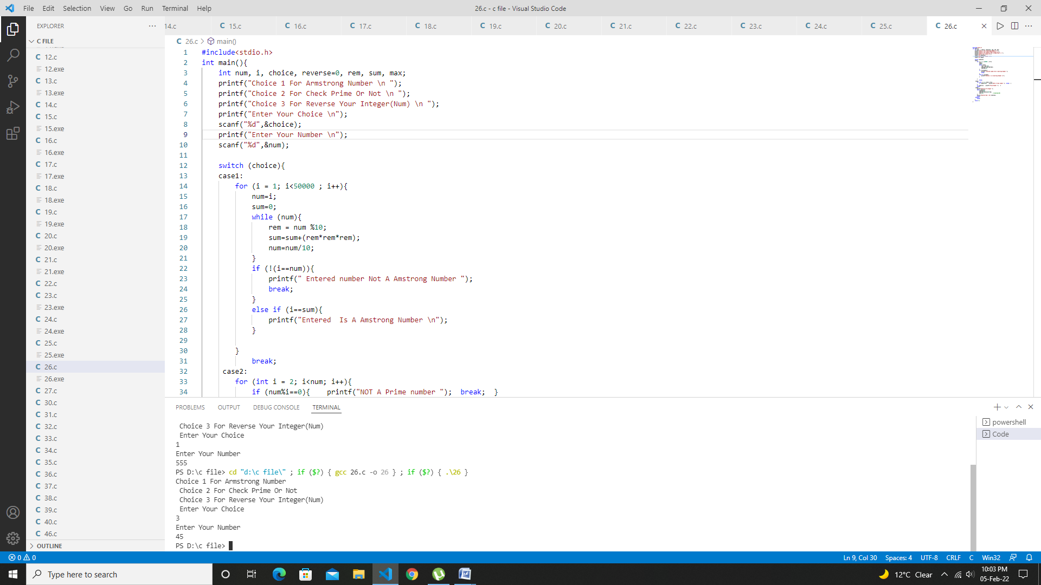

***Program28-write a program in C to swap two number using call by value.***

#include<stdio.h>

int swap(int,int);

int main(){

    int a=10,b=20;

    swap(a,b);

    return 0;

}

int swap(int X,int Y){

     int temp;

     temp = X;

     X = Y;

     Y = temp;

     printf("\n x=%d y=%d", X, Y);

}

Test Data

Output:

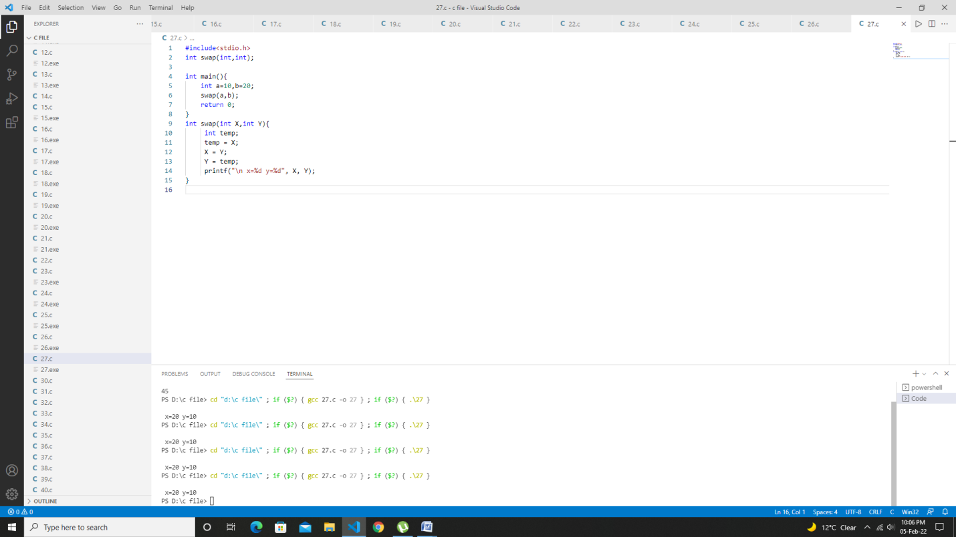

***Program29:-write a program in C to swap two number using call by refference.***

#include<stdio.h>     
void change(int num) {       
    printf("Before adding value inside function num=%d \n",num);       
    num=num+100;       
    printf("After adding value inside function num=%d \n", num);       
}       
int main() {       
    int x=100;       
    printf("Before function call x=%d \n", x);       
    change(x);//passing value in function       
    printf("After function call x=%d \n", x);       
return 0;     
}

Test Data

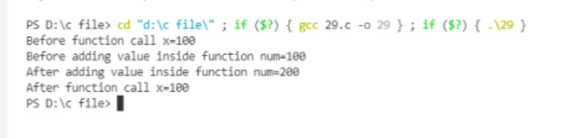Output

***Program30:-write a program in C to find the Area of a circle using call by reference.***

#include<stdio.h>

void area_peri(float, float*, float*);

int main()

{

    float radius, area, perimeter;

    printf("Enter radius of Circle\n");

    scanf("%f", &radius);

    area_peri(radius, &area, &perimeter);

    printf("\nArea of Circle = %0.2f\n", area);

    printf("Perimeter of Circle = %0.2f\n", perimeter);

    return 0;

}

void area_peri(float r, float *a, float *p)

{

    *a = 3.14 * r * r;

    *p = 2 * 3.14 * r;

}

Test Data

Output:

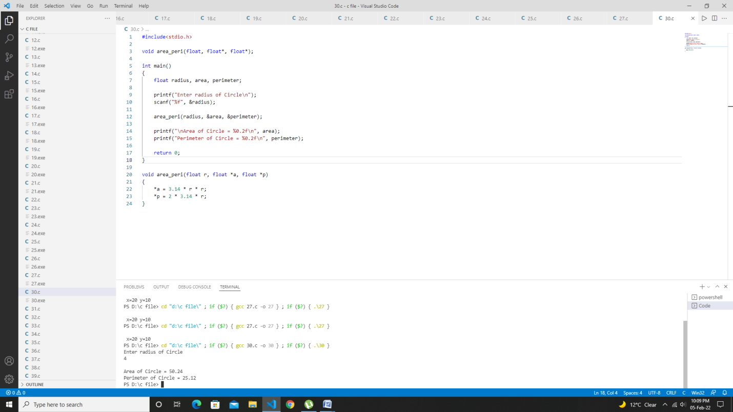

***Program 31: Write a program to add, subtract, multiply and divide two numbers using pointers and Using function.***

#include<stdio.h>

int add(int*,int*);

int Sub(int*x,int*y);

int Mult(int*x,int*y);

int Divide(int*x,int*y);

int main(){

   int a, b, sum, sub, mul, div;

   printf("\n Enter Your Two Number = \n");

   scanf("%d %d",&a,&b);

   sum=add(&a,&b);

   sub = Sub(&a,&b);

   mul=Mult(&a,&b);

   div = Divide(&a,&b);

   printf("This Is Sum = %d\n",sum);

   printf("This Is Subtract = %d\n",sub);

   printf("This Is Multiply = %d\n",mul);

   printf("This Is Divide = %d\n",div);

   return 0;

}

int add(int*x,int*y){

      int sum;

      sum =(*x)+(*y);

      return sum;

}

int Sub(int*x,int*y){

      int sub;

      sub =(*x)-(*y);

      return sub;

}

int Mult(int*x,int*y){

      int M;

      M =(*x)*(*y);

      return M;

}

int Divide(int*x,int*y){

      int Div;

      Div =(*x)/(*y);

      return Div;

}

Test Data

Output:

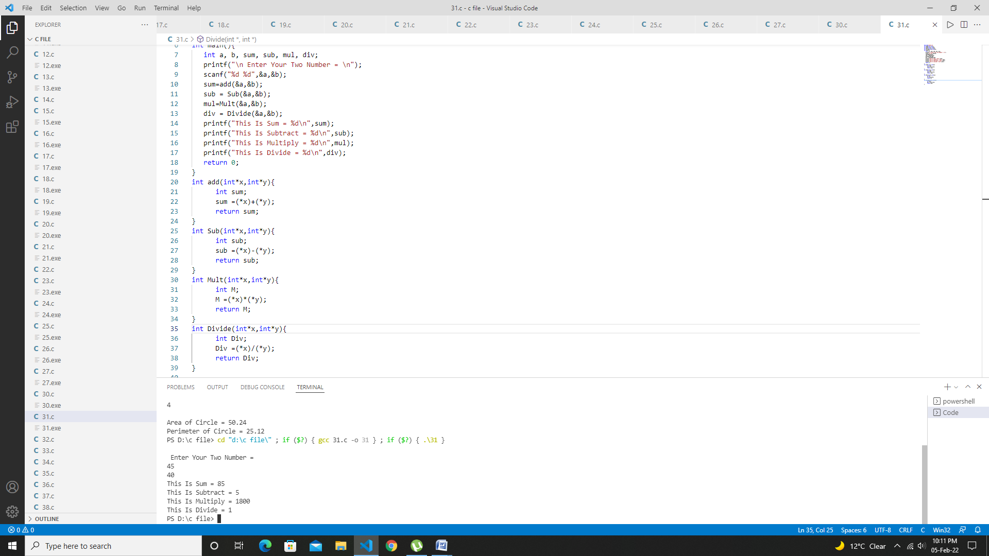

***Program 32:-write a program to input marks of 50 students using an Array and display the Average marks of the class.***

#include<stdio.h>

int main(){

    int marks[50],sum=0,Avg;

    printf("Enter Marks Of 50 Student = \n");

    for (int i = 0; i<50; i++)

    {

        scanf("%d",&marks[i]);

        sum=sum+marks[i];

    }

    Avg=sum/50;

    printf("Avg Is %d",Avg);

    return 0;

}

Test Data

Output:

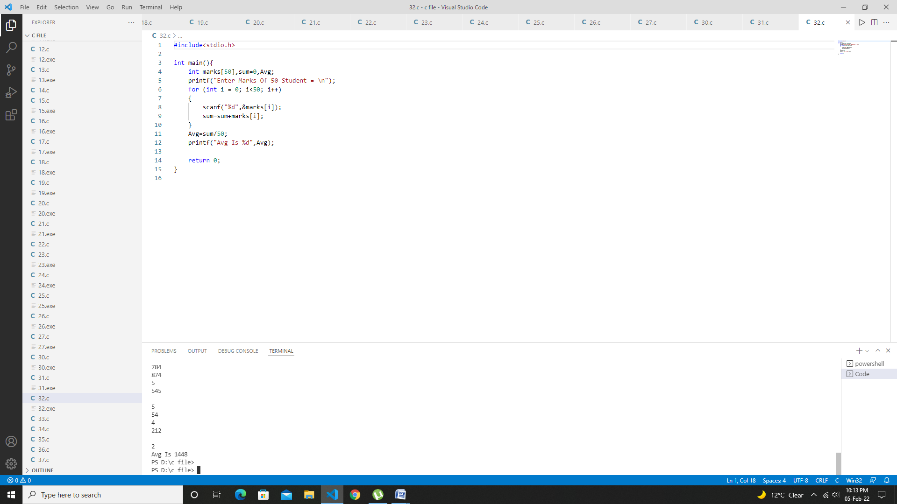

***Program 33:-Write a program to search for a number entered by the user in a given array.***

#include<stdio.h>

int main(){

    int num,n[10],i;

    printf("Enter 10 Number \n");

    for (int i = 0; i<10; i++){

        scanf("%d",&n[i]);

    }

    printf("Enter Your Number You Want To Search In List \n");

    scanf("%d",&num);

    for ( i = 0; i<10; i++)

    {

        if (num==n[i]){

            printf("Number Is Found \n");

            break;

        }

    }

    printf("When Your Num Not Found Print Nothing");

    return 0;

}

Test Data

Output:

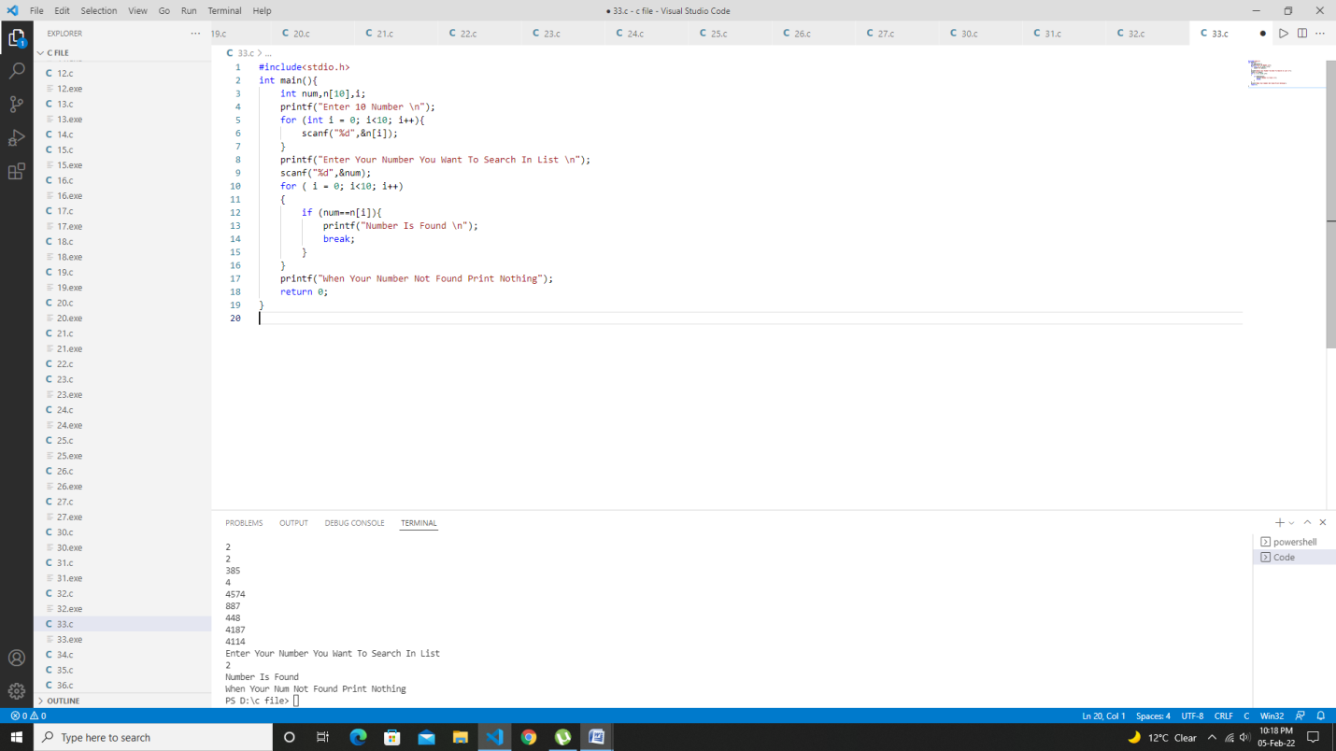

***Program 34:-write a program in C to pass array elements to a function.***

#include<stdio.h>

void display(int);

int main(){

    int i;

    int  marks[]={67 ,79, 85, 69, 20};

    for ( i = 0; i<5; i++)

    {

        display(marks[i]);

    }

    return 0;

}

void display(int m){

      printf("%d\n ",m);

}

Test Data

Output:

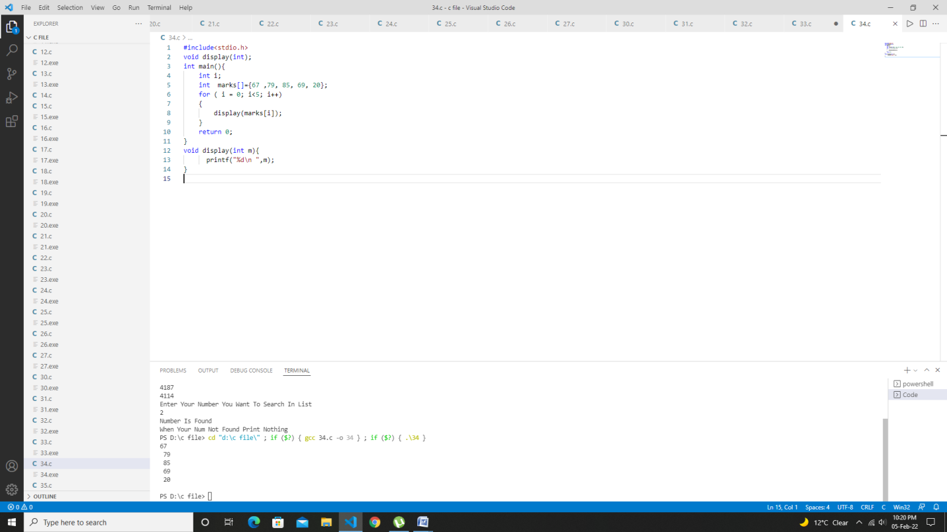

***Program 35:-Write a program in C to print the following pattern.***

#include<stdio.h>

int main(){

    int i, j, num;

    printf("Enter Your Number You Want How Many Rows \n");

    scanf("%d",&num);

    for ( i = 0; i<num ; i++){

        for ( j = 0; j<=i; j++){    printf("*");    }

        printf("\n");

    }

    return 0;

}

Test Data

Output:

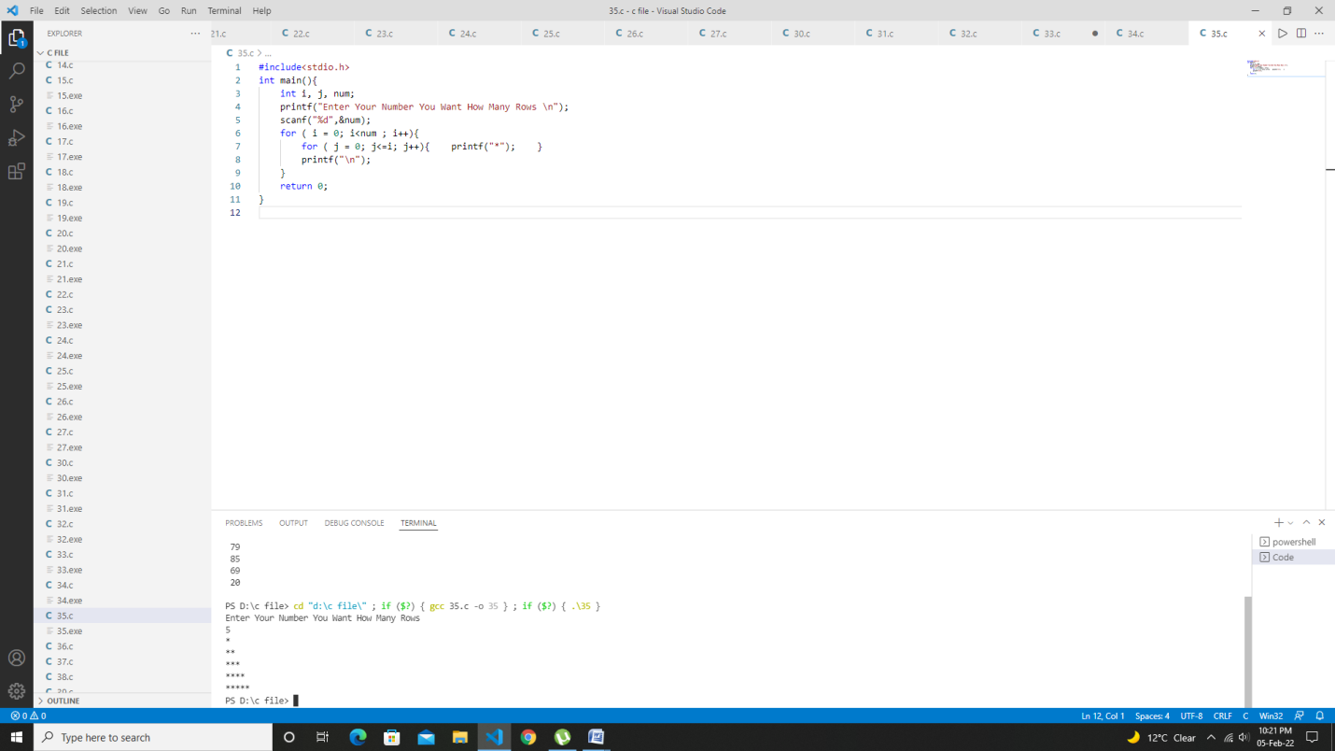

***Program 36:-Write a program in C to print the Inverted half pyramid of Star***.

#include<stdio.h>

int main(){

    int i, j, rows;

    printf("Enter Your Number You Want How Many Rows \n");

    scanf("%d",&rows);

    for ( i =rows; i>=1 ; i--)

    {

        for ( j = 1; j<=i; j++){    printf("*");    }

        printf("\n");

    }

    return 0;

}

Test Data

Output:

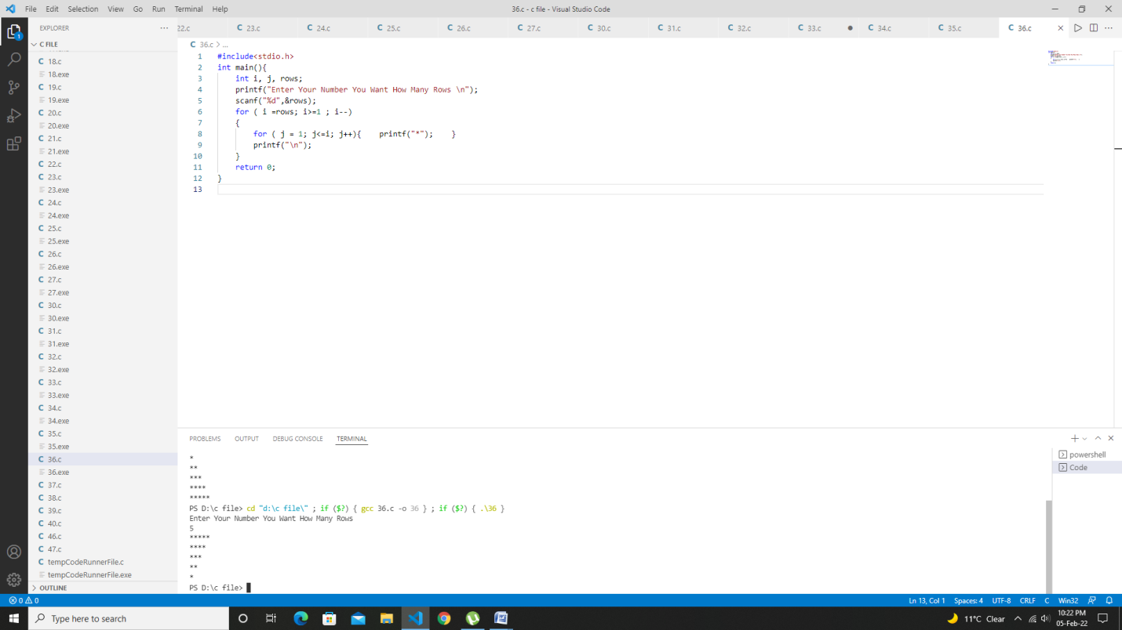

***Program 37:-Write a program in C to print the Half Pyramid of Numbers.***

#include<stdio.h>

int main(){

    int i, j, rows;

    printf("Enter Your Number You Want How Many Rows \n");

    scanf("%d",&rows);

    for ( i =1; i<=rows ; i++)

    {

        for ( j = 1; j<=i; j++){    printf("%d",j);    }

        printf("\n");

    }

    return 0;

}

Test Data

Output:

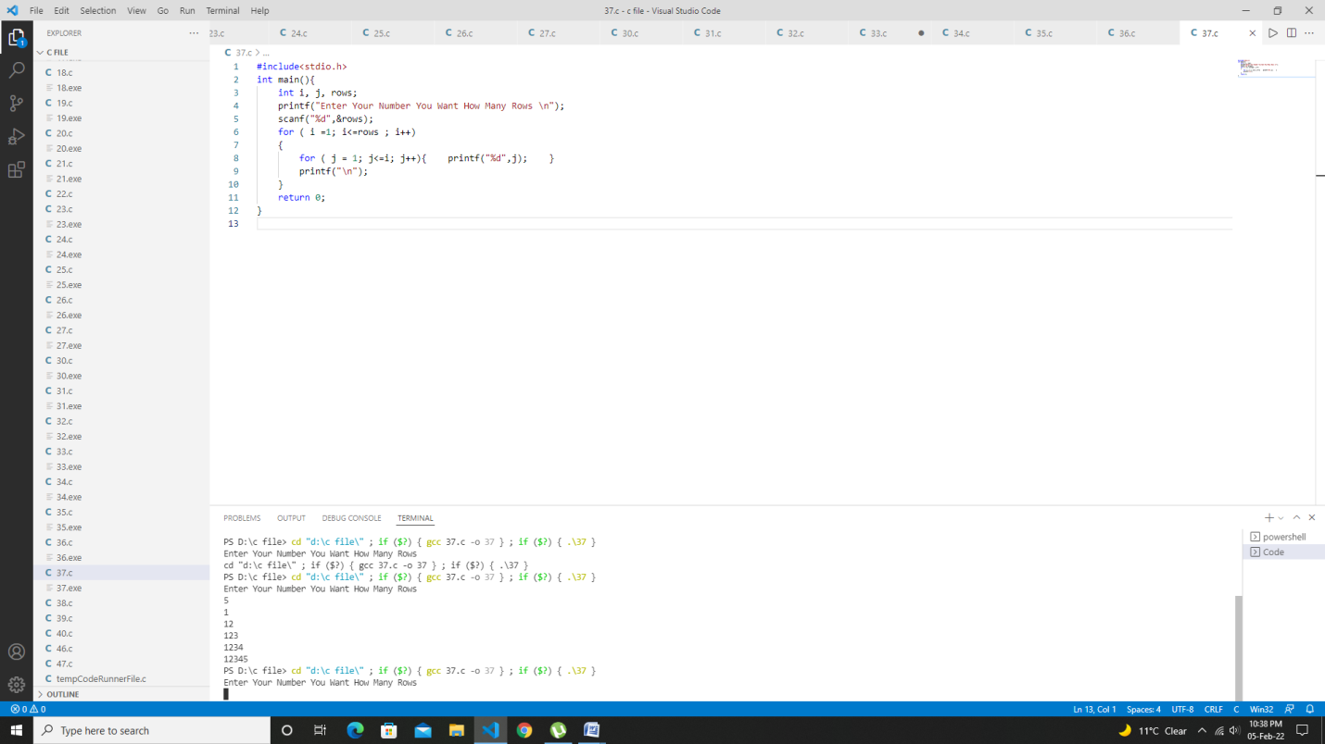

***Program 38:-Write a program in C to print the full-Pyramid of Numbers.***

#include<stdio.h>

int main(){

    int rows, number=1;

    printf("Enter Your Rows You Want To Print Pyramid \n");

    scanf("%d",&rows);

    for (int i = 0 ; i<=rows; i++)

    {

        for (int k = 0; k<=rows-i; k++){    printf(" ");    }

        for (int j = 0; j <=(1*i-1); j++){    printf(" %d ",number);  ++number;    }

        printf(" \n ");

    }

    return 0;

}

Test Data

Output:

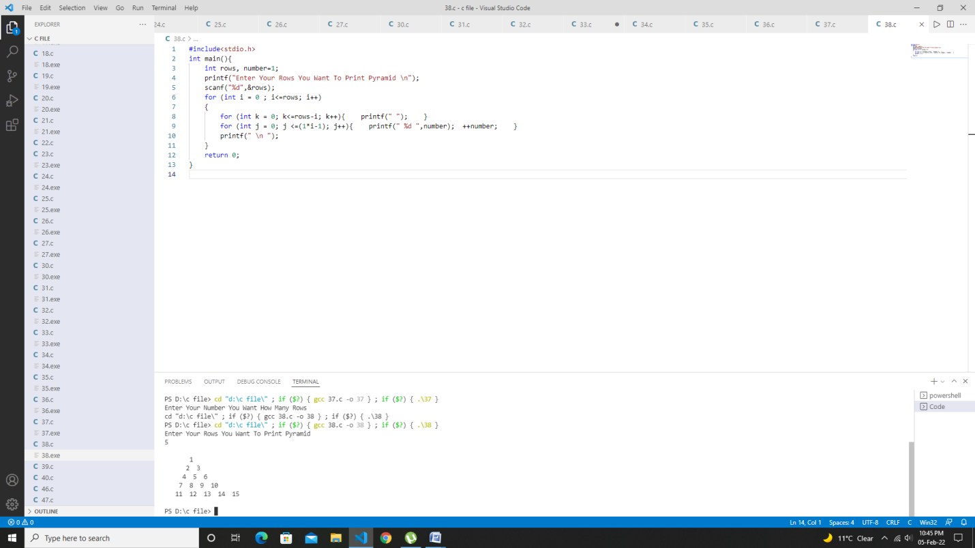

***Program 39: write a program using pointer to compute the sum of all elements Stored in the Array***

#include<stdio.h>

int main(){

    int arr[5];

    int Sum=0,*p,i,j=0;

    printf("Enter 5 element You Want To Sum \n");

    for ( i = 0; i<5; i++)

    {

        scanf("%d",&arr[i]);

    }

    p=arr;

    while (j<5)

    {

        printf(" \n%d. %d",j,*p);

        Sum = Sum+*p;

        j++;

        p++;

    }

    printf("\n Sum Of All Elements = %d ",Sum);

    return 0;

}

Test Data

Output:

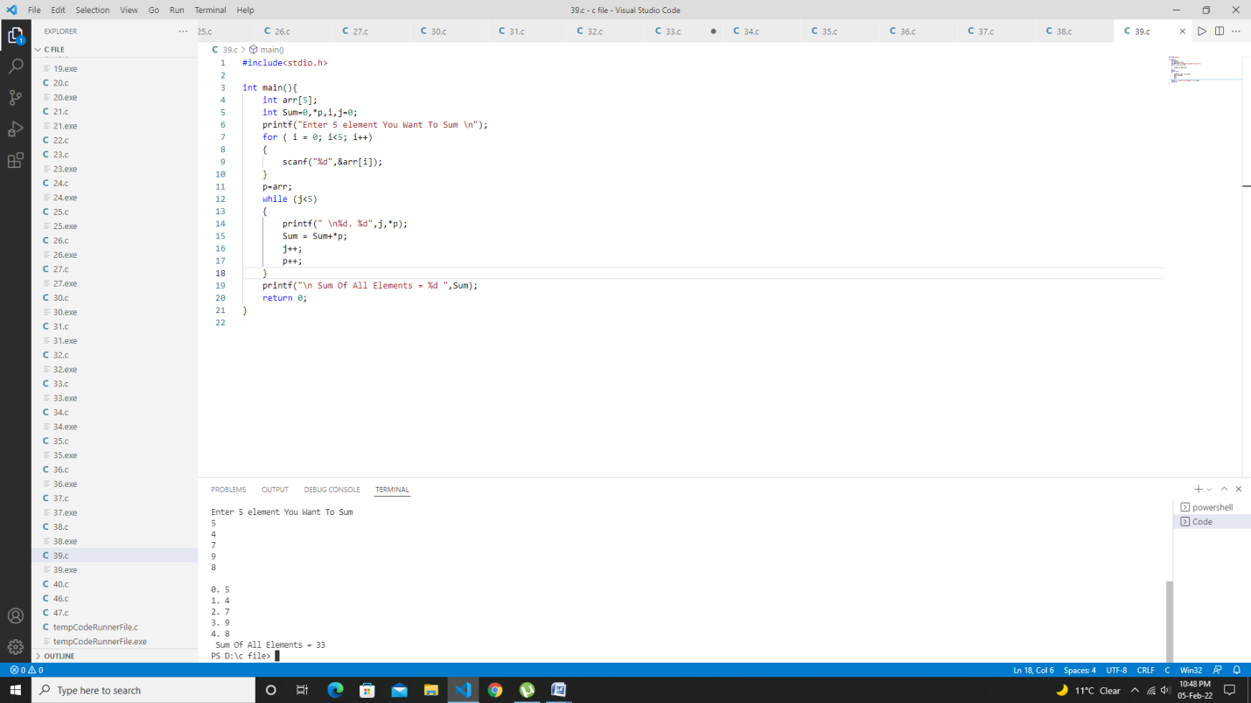

***Program 40:Write a program in ‘C’ pointer to sort the elements.***

#include<stdio.h>

int sort(int ,int *);

int main(){

    int arr[10],i,n;

    printf("Enter How Much Element You Want To Short \n");

    scanf("%d",&n);

    printf("Enter Elements One By One \n");

    for (int i = 0; i< n; i++){

        scanf("%d",&arr[i]);

    }

    sort(n,arr);

    for(i=0;i<n;i++)

    printf("\t%d",arr[i]);

    return 0;

}

int sort(int l, int*p){

    int i, j, temp;

    for ( i = 0; i< l; i++)

    for ( j = 0; j < l; j++)

    {

        if (*(p+j)>=*(p+j+1))

        {

            temp=*(p+j);

            *(p+j)=*(p+j+1);

            *(p+j+1)=temp;

        }

    }

    return 0;

}

Test Data

Output:

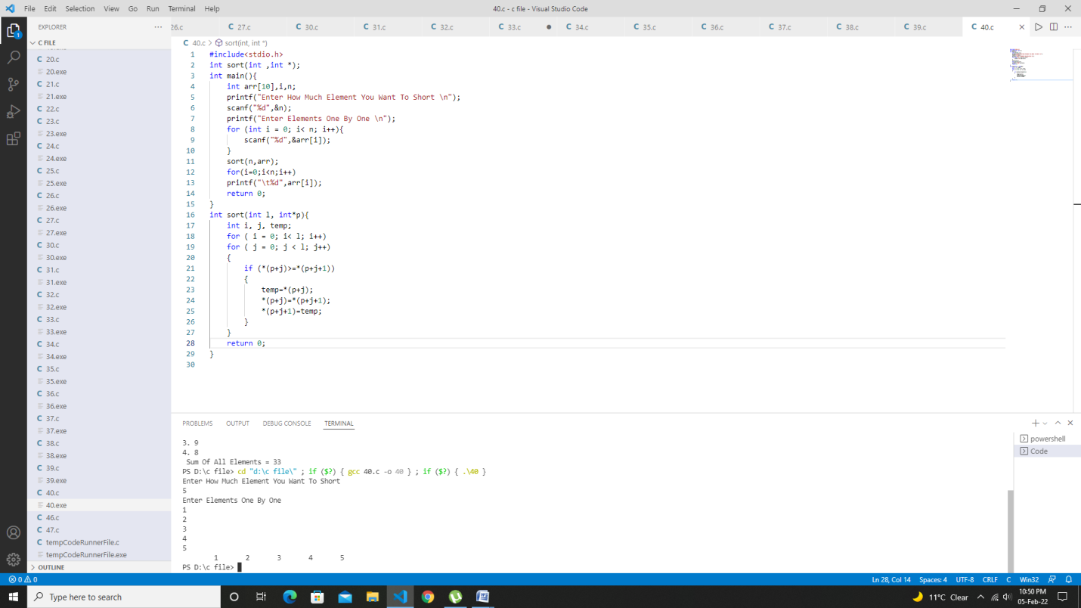

***Program 41: Write a program in C to show the use of malloc and free function.***

#include<stdio.h>

#include<conio.h>

#include<malloc.h>

void main( )

{

char *ch;

int *p;

float *f;

ch = (char*)malloc(sizeof(char));

    p = (int*)malloc(sizeof(int));

    f = (float*)malloc(sizeof(float));

printf("Enter a Character\n");

  *ch = getchar();                    //scanf("%c",ch);

printf("Enter an Integer\n");

scanf("%d",p);

printf("Enter a Float\n");

scanf("%f",f);

printf(" You entered \n%c %d %f",*ch,*p,*f);

free(ch);

free(p);

free(f);

 }

Output

: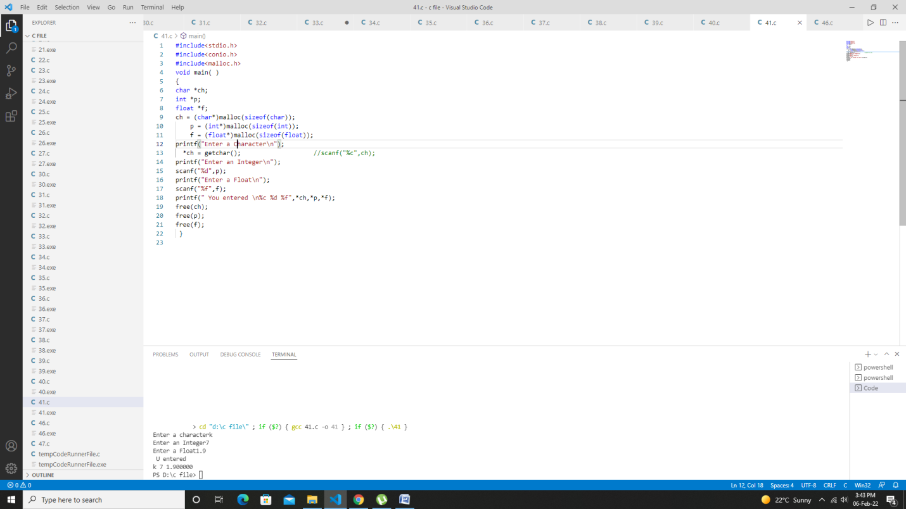

***Program 42: Write a program to show the concept of dynamicmemory allocation for an array.***

#include<stdio.h>

#include<conio.h>

void main()

{

int *p,n,i;

printf("Enter the size of an array");

scanf("%d",&n);

    p = (int*)malloc(sizeof(int)*n);

for(i=0;i<n;i++)

    {

printf("\n Enter p[%d] element",i);

scanf("%d",p+i);

    }

printf("Array Elements are");

for(i=0;i<n;i++)

    {

printf("p[%d]= %d\n",i,*(p+i));

    }

free(p);

}

Output:

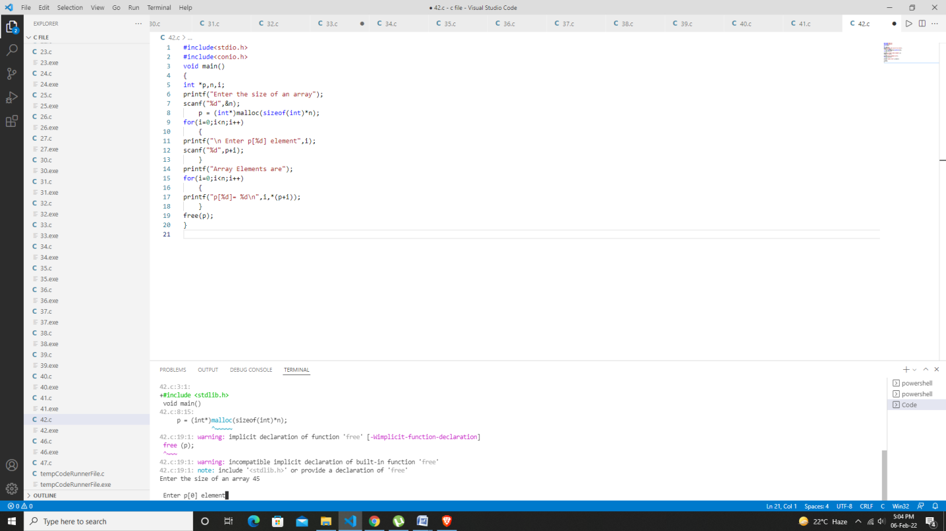

***Program 43: Write a program to perform matrix addition, multiplication and transpose***

#include <stdio.h>

int main()

{

//fill your code

int m, n;

scanf(“%d %d”,&m,&n);

int i, j;

int mat1[m][n], mat2[m][n], mat3[m][n];

for(i = 0; i < m; i++)

{

for(j = 0; j < n; j++)

scanf(“%d”,&mat1[i][j]);

}

Output:

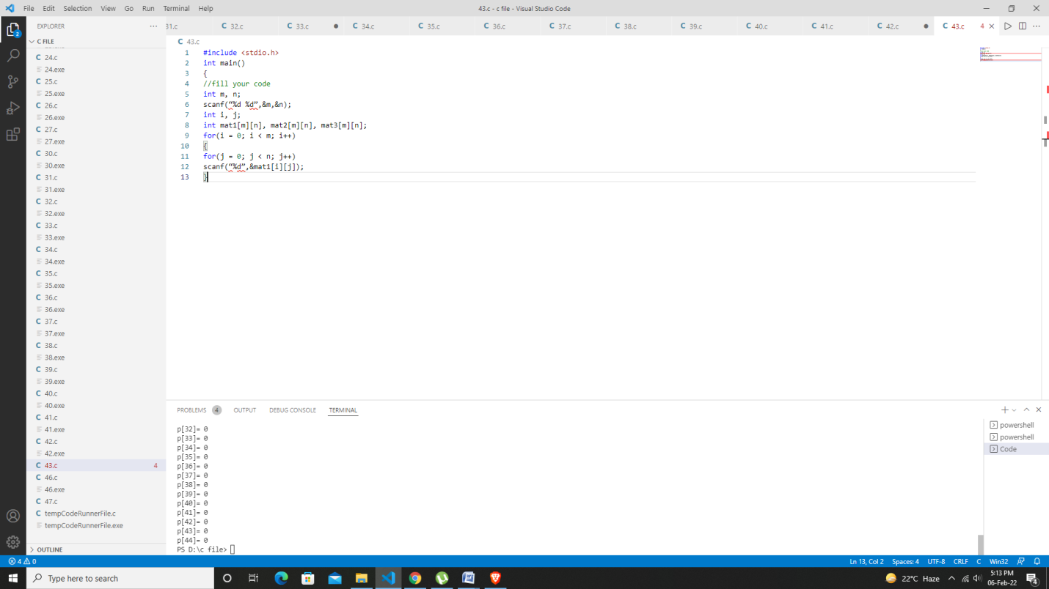

***Program 44: Write a program to check if string is a palindrome or not ,using predefined function strcmp.***

#include <stdio.h>

#include <string.h>

int main()

{

    char s[1000];

    int i,n,c=0;

    printf("Enter  the string : \n");

    gets(s);

    n=strlen(s);

    for(i=0;i<n/2;i++)

    {

        if(s[i]==s[n-i-1])

        c++;

    }

    if(c==i)

        printf("string is palindrome");

    else

        printf("string is not palindrome");

    return 0;

}

Output:

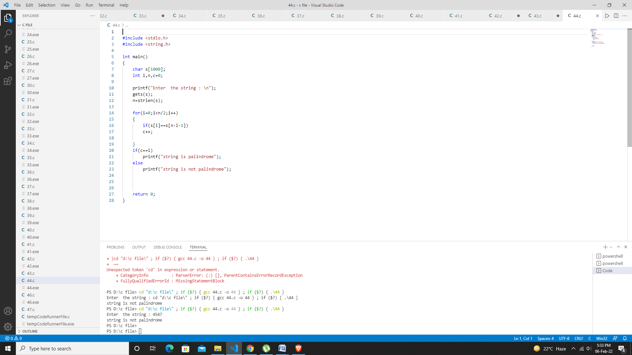

***Progam45: Write a program to check if string is a palindrome or not ,without using predefined function.***

#include <stdio.h>

#include <string.h>

void main()

{

    char string[25], reverse_string[25] = {'\0'};

    int i, length = 0, flag = 0;

    printf("Enter a string \n");

    gets(string);

    /*  keep going through each character of the string till its end */

    for (i = 0; string[i] != '\0'; i++)

    {

        length++;

    }

    printf("The length of the string '%s' = %d\n", string, length);

    for (i = length - 1; i >= 0 ; i--)

    {

        reverse_string[length - i - 1] = string[i];

    }

   /*  Check if the string is a Palindrome */

    for (flag = 1, i = 0; i < length ; i++)

    {

        if (reverse_string[i] != string[i])

            flag = 0;

    }

    if (flag == 1)

       printf ("%s is a palindrome \n", string);

    else

       printf("%s is not a palindrome \n", string);

}

Output:

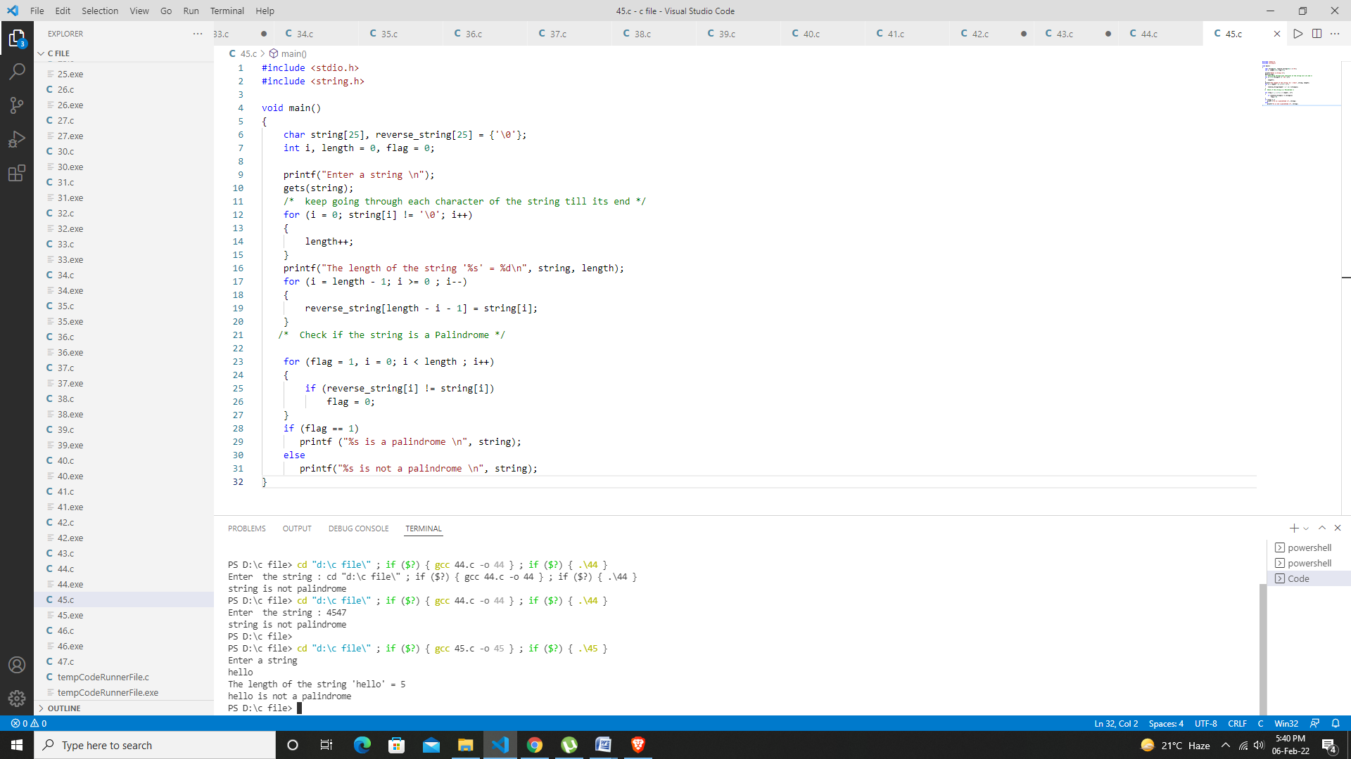

***Program 46: Write a menu driven program to implement following operations:***

***(i) Calculate length of string***

***(ii) Concatenate at the end of a given string***

***(iii) Copy one string to another***

***(iv) Compare contents of two strings***

***(v) Copy nth character string to anoth***er.

#include<stdio.h>

#include<string.h>

#include<stdlib.h>

int main()

{

    char str1[20],str2[20];

    int ch,i,j;

    do

    {

        printf("\tMENU");

        printf("\n------------------------------\n");

        printf("1:Find Length of String");

        printf("\n2:Find Reverse of String");

        printf("\n3:Concatenate Strings");

        printf("\n5:Copy String ");

        printf("\n5:Compare Strings");

        printf("\n6:Exit");

        printf("\n------------------------------\n");

        printf("\nEnter your choice: ");

        scanf("%d",&ch);

        switch(ch)

        {

            case 1:

                printf("Enter String: ");

                scanf("%s",str1);

                i=strlen(str1);

                printf("Length of String : %d\n\n",i);

            break;

            case 2:

                printf("Enter String: ");

                scanf("%s",str1);

                //strrev(str1);

                printf("Reverse string : %s\n\n",str1);

            break;

            case 3:

                printf("\nEnter First String: ");

                scanf("%s",str1);

                printf("Enter Second string: ");

                scanf("%s",str2);

                strcat(str1,str2);

                printf("String After Concatenation : %s\n\n",str1);

            break;

            case 4:

                printf("Enter a String1: ");

                scanf("%s",str1);

                printf("Enter a String2: ");

                scanf("%s",str2);

                printf("\nString Before Copied:\nString1=\"%s\",String2=\"%s\"\n",str1,str2);

                strcpy(str2,str1);

                printf("-----------------------------------------------\n");

                printf("\"We are copying string String1 to String2\" \n");

                printf("-----------------------------------------------\n");

                printf("String After Copied:\nString1=\"%s\", String2=\"%s\"\n\n",str1,str2);

            break;

            case 5:

                printf("Enter First String: ");

                scanf("%s",str1);

                printf("Enter Second String: ");

                scanf("%s",str2);

                j=strcmp(str1,str2);

                if(j==0)

                {

                    printf("Strings are Same\n\n");

                }

                else

                {

                    printf("Strings are Not Same\n\n");

                }

            break;

            case 6:

                exit(0);

            break;

            default:

                printf("Invalid Input. Please Enter valid Input.\n\n ");

        }

    }while(ch!=6);

    return 0;

Output:

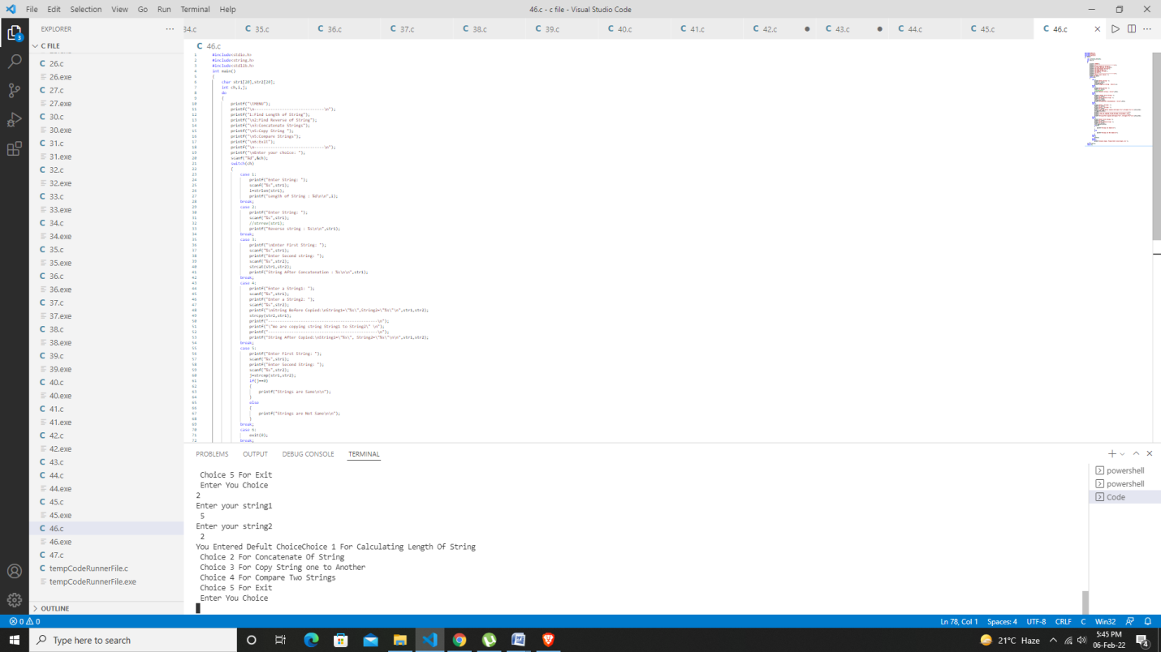

***Program 47:Write a program to calculating factorial with recursive function or Recursion***

#include<stdio.h>

int Recursion(int);

int main(){

    int num, fact;

    printf("Enter Your Number ");

    scanf("%d",&num);

   fact= Recursion(num);

    printf("Factorial Value Is %d",fact);

    return 0;

}

int Recursion(int x){

    int f;

    if (x==1)

    {

        return(1);

    }

    else{

        f = x * Recursion(x-1); // x=4 ,f=4*rec(3) //x=3 f = 3*recursion(2) // x = 2 f=2*recursion(1)

    }

    return f;

}

Output:

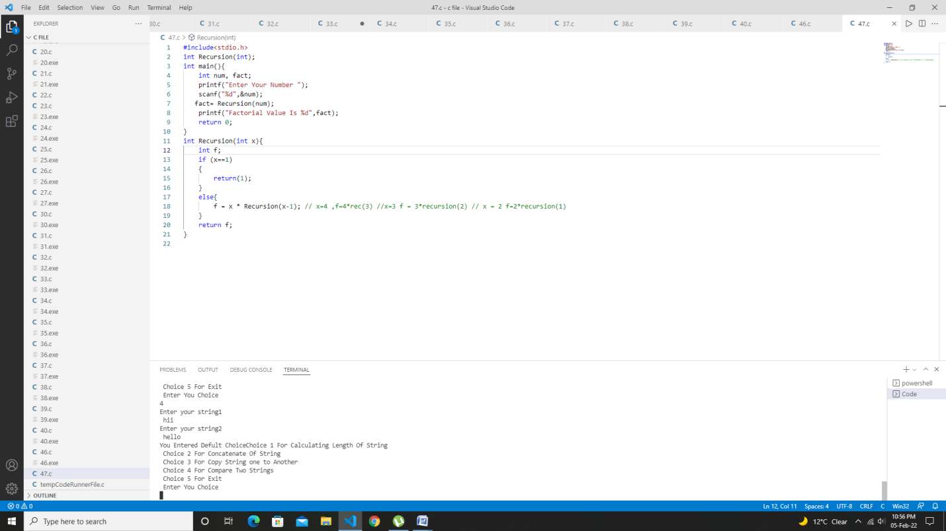

***Program 48: Write a program to convert hexadecimal into binary number.***

#include <stdio.h>

#include <string.h>

int main()

{

char hex[17], bin[65] = "";

int i = 0;

printf("Enter any hexadecimal number: ");

gets(hex);

for(i=0; hex[i]!='\0'; i++)

{

switch(hex[i])

{

case '0':

strcat(bin, "0000");

break;

case '1':

strcat(bin, "0001");

break;

case '2':

strcat(bin, "0010");

break;

case '3':

strcat(bin, "0011");

break;

case '4':

strcat(bin, "0100");

break;

case '5':

strcat(bin, "0101");

break;

case '6':

strcat(bin, "0110");

break;

case '7':

strcat(bin, "0111");

break;

case '8':

strcat(bin, "1000");

break;

case '9':

strcat(bin, "1001");

break;

case 'a':

case 'A':

strcat(bin, "1010");

break;

case 'b':

case 'B':

strcat(bin, "1011");

break;

case 'c':

case 'C':

strcat(bin, "1100");

break;

case 'd':

case 'D':

strcat(bin, "1101");

break;

case 'e':

case 'E':

strcat(bin, "1110");

break;

case 'f':

case 'F':

strcat(bin, "1111");

break;

default:

printf("Invalid hexadecimal input.");

}

}

printf("Hexademial number = %s\n", hex);

printf("Binary number = %s", bin);

return 0;

}

Output:

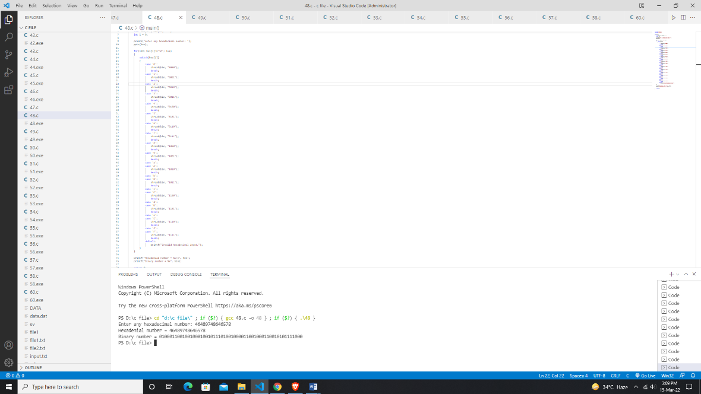

***Program 49: Write a program to create a structure for students containing the following data members.***

***Name of the student***

***Roll number of the student***

***Marks of the student***

***Input data of students & display the details of the student id given by the user.***

#include <stdio.h>

struct student

{

    char name[50];

    int roll;

    float marks;

};

int main()

{

    struct student s;

 printf("Enter The Information of Students :\n\n");

 printf("Enter Name : ");

    scanf("%s",s.name);

 printf("Enter Roll No. : ");

    scanf("%d",&s.roll);

    printf("Enter marks : ");

    scanf("%f",&s.marks);

    printf("\nDisplaying Information\n");

 printf("Name: %s\n",s.name);

    printf("Roll: %d\n",s.roll);

    printf("Marks: %.2f\n",s.marks);

    return 0;

}

Output:

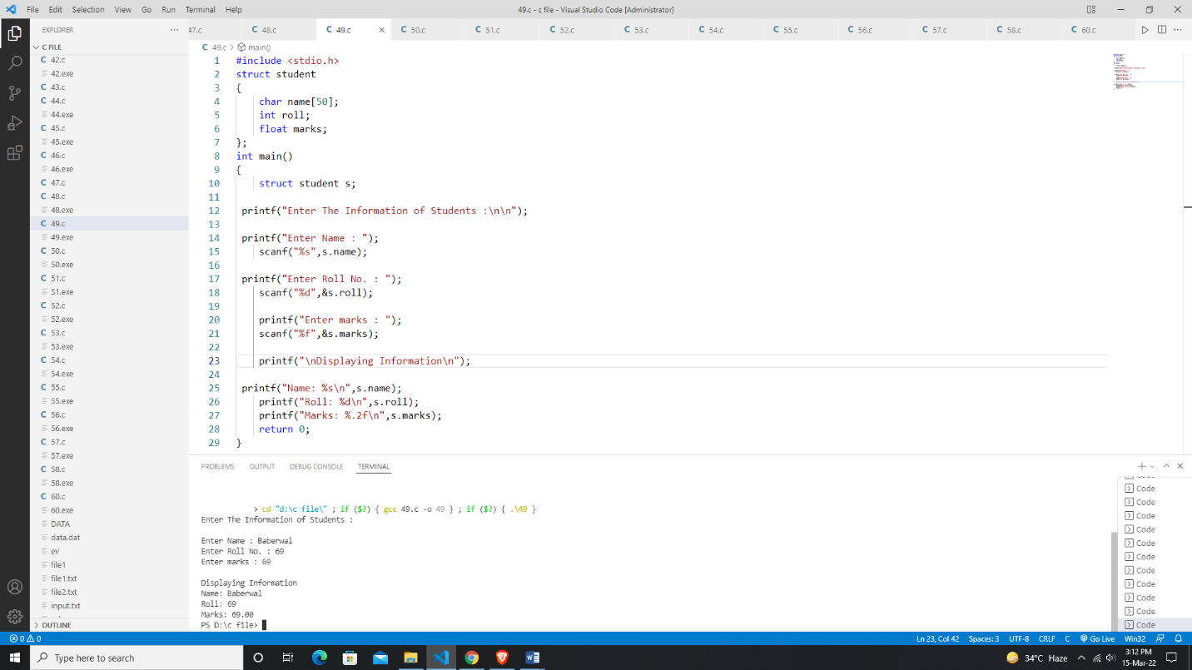

***Program 50: Write a program to pass address of a struct variable to a user defined function and display the content.***

#include <stdio.h>

struct student {

   char name[50];

   int age;

};

void display(struct student s);

int main() {

   struct student s1;

   printf("Enter name: ");

   scanf("%[^\n]%*c", s1.name);

   printf("Enter age: ");

   scanf("%d", &s1.age);

   display(s1);

   return 0;

}

void display(struct student s) {

   printf("\nDisplaying information\n");

   printf("Name: %s", s.name);

   printf("\nAge: %d", s.age);

}

Output:

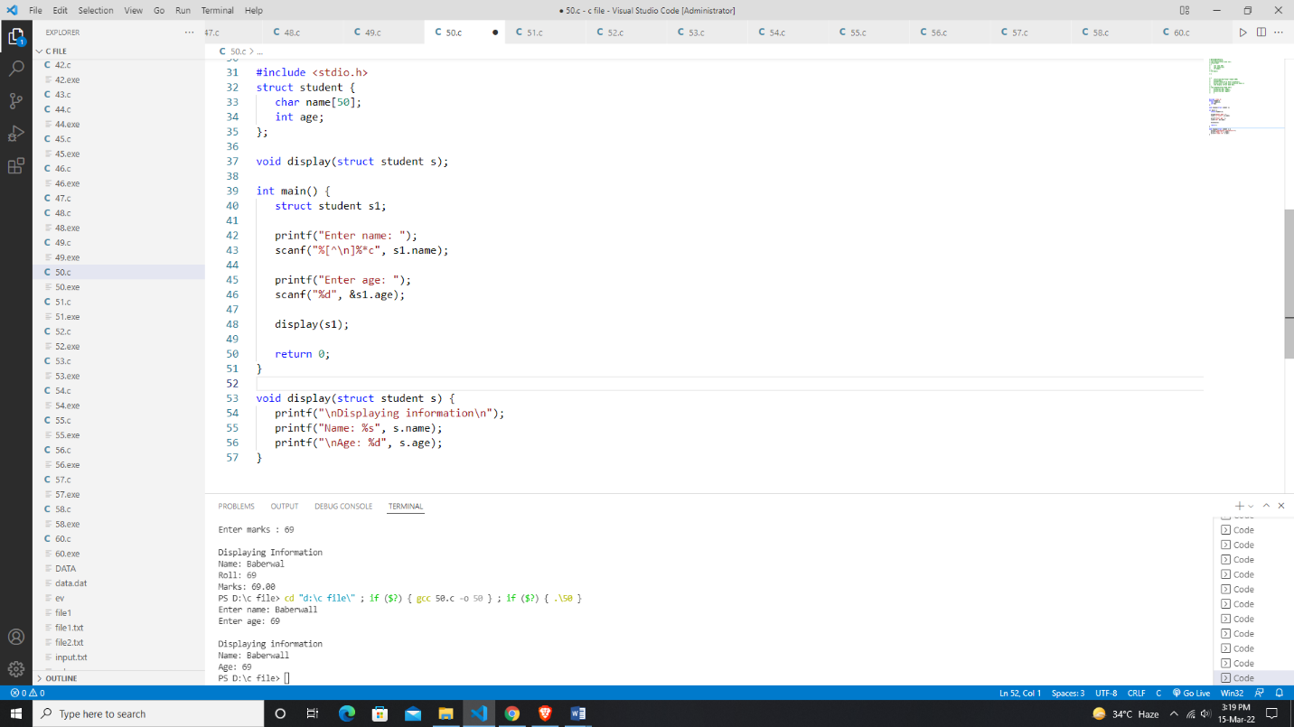

***Program 51: Write a program to make use of array with structure in following way:***

1. ***Use array as a structure data member.***
2. ***Create array of structure variable*.**

***Program 52: Write a program to show the use of concept of enumeration.***

#include<ctype.h>

#include<stdio.h>

#include<conio.h>

void main()

{

char ch;

int f;

enum ctype

{

letter,digit,other

};

printf("Enter any character: \n");

ch=getch();

f=isalpha(ch);

if(f!=0)

{

printf("\n%c is type %d symbol",ch,letter);

}

else

{

f=isdigit(ch);

}

if(f!=0)

{

printf("\n%c is type %d symbol",ch,digit);

}

else

{

printf("\n%c is type %d symbol",ch,other);

}

}

Output:

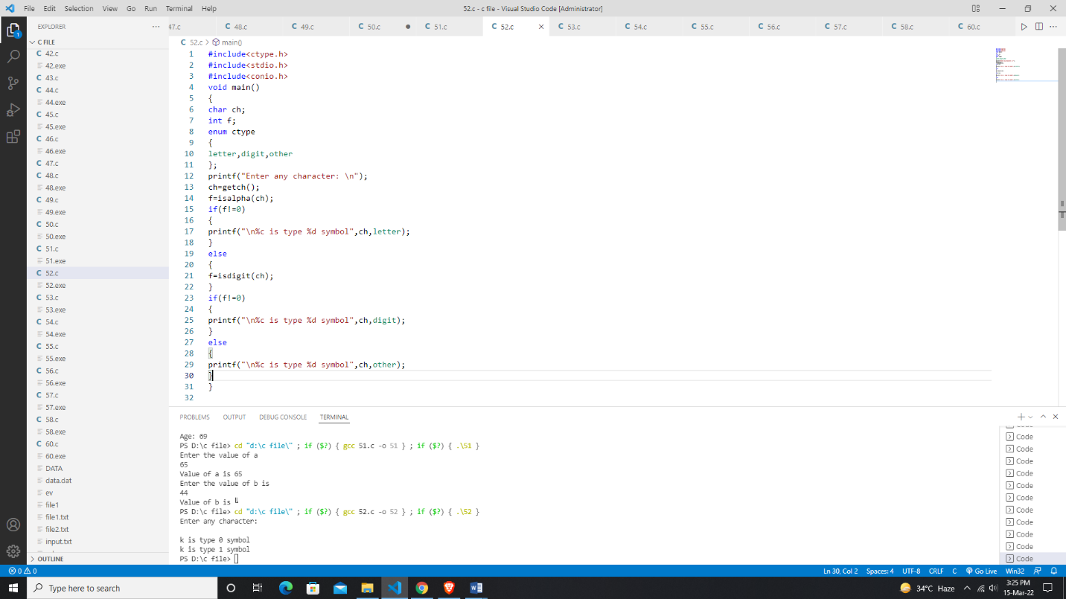

***Program 53: Write a program to illustrate difference between structure and array.***

#include<ctype.h>

#include<stdio.h>

#include<conio.h>

int main(){

    char ch;

    int f;

    enum  etype{

        letter, digit, other

    };

    printf("\n Enter any character: ");

    ch=getch();

    f=isalpha(ch);

    if(f!=0){

        printf("%c is type %d symbol",ch,letter);

    }

     else{

         f=isdigit(ch);

     if (f!=0){

         printf("\n%c is type %d symbol",ch,digit);

     }

         else{

    printf("\n%c is type %d symbol",ch,other);

     }

     }

    }

Output:

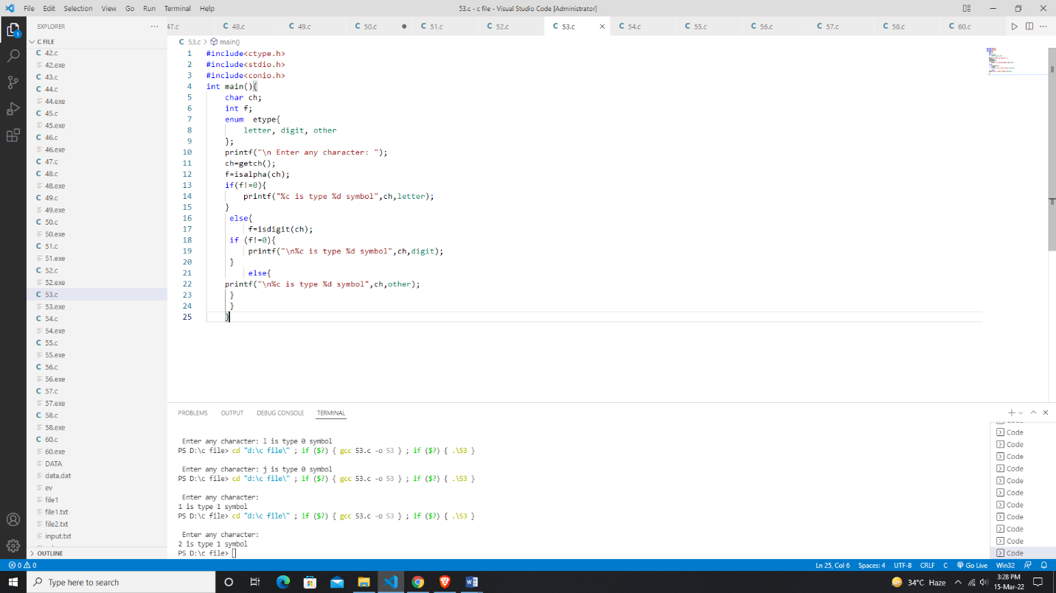

***Program 54: Write a program to read the data from the keyboard, write it to the file named “input” and again read the data from the “input” file and display it on the screen.***

#include<stdio.h>

#include<conio.h>

#include<process.h>

int main()

{

    FILE *fp;

    char ch;

    fp = fopen("input.txt","w");

    if(fp==NULL)

    {

        printf("Can not open file");

        exit(1);

    }

    printf("Write data & press '.' to stop press\n");

    while(ch!='.')

    {

        ch =getche();

        putc(ch,fp);

    }

    fclose(fp);

    printf("\nContent read");

    fp=fopen("Input.txt","r");

    while(feof(fp))

    {

      printf("%c",getc(fp));

    }

    return 0;

}

Output:

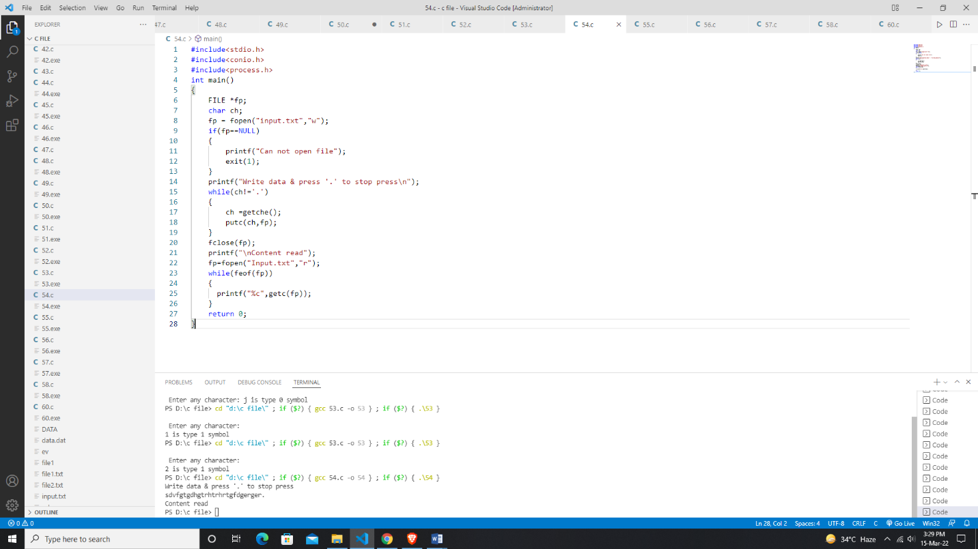

***Program 55: Write a program to open pre-existing file and add the information at the end of the file.***

***Program 56: Write a program to open a file for read or write operation in binary mode. Read and write new information in file.***

# include <stdio.h>

# include <conio.h>

# include <process.h>

void main()

{

    FILE*fp;

    char ch;

    fp=fopen("data.dat", "wb");

    if(fp==NULL)

    {

        printf("file don't exist");

        exit(1);

    }

    printf("write data & to stop press (.) \n");

    while(ch!='.')

    {

        ch=getche();

        fputc(ch,fp);

    }

    fclose(fp);

    fp=fopen("data.dat","rb");

    while(!feof(fp))

    {

        ch=fgetc(fp);

        printf("%c",ch);

    }

    fclose(fp);

}

Output: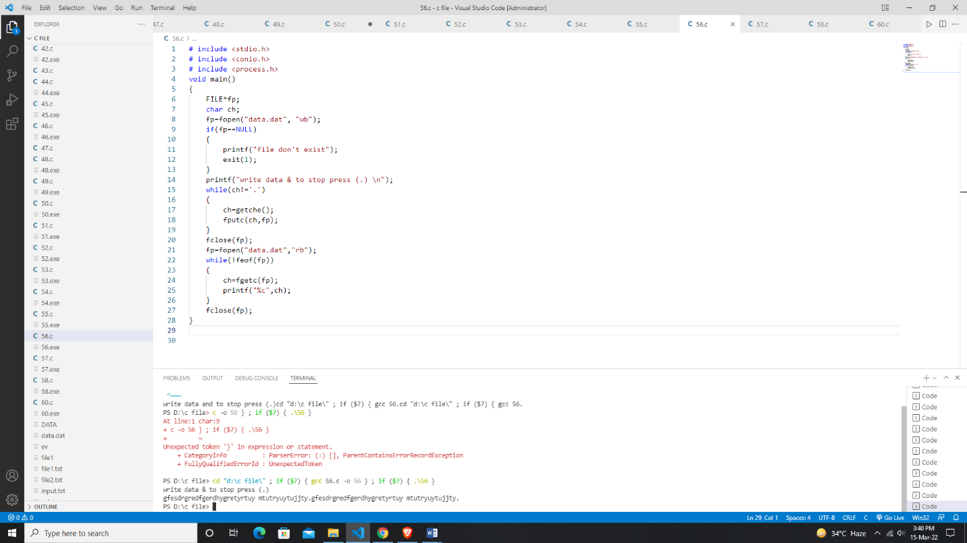

***Program 57: Write a program to open a text file and write some text file using fprintf() function.***

#include<stdio.h>

#include<conio.h>

void main()

{

FILE *fp;

char text[30];

fp=fopen("Text.txt","w");

printf("enter text in the file \n");

gets(text);

fprintf(fp,"%s",text);

fclose(fp);

}

Output: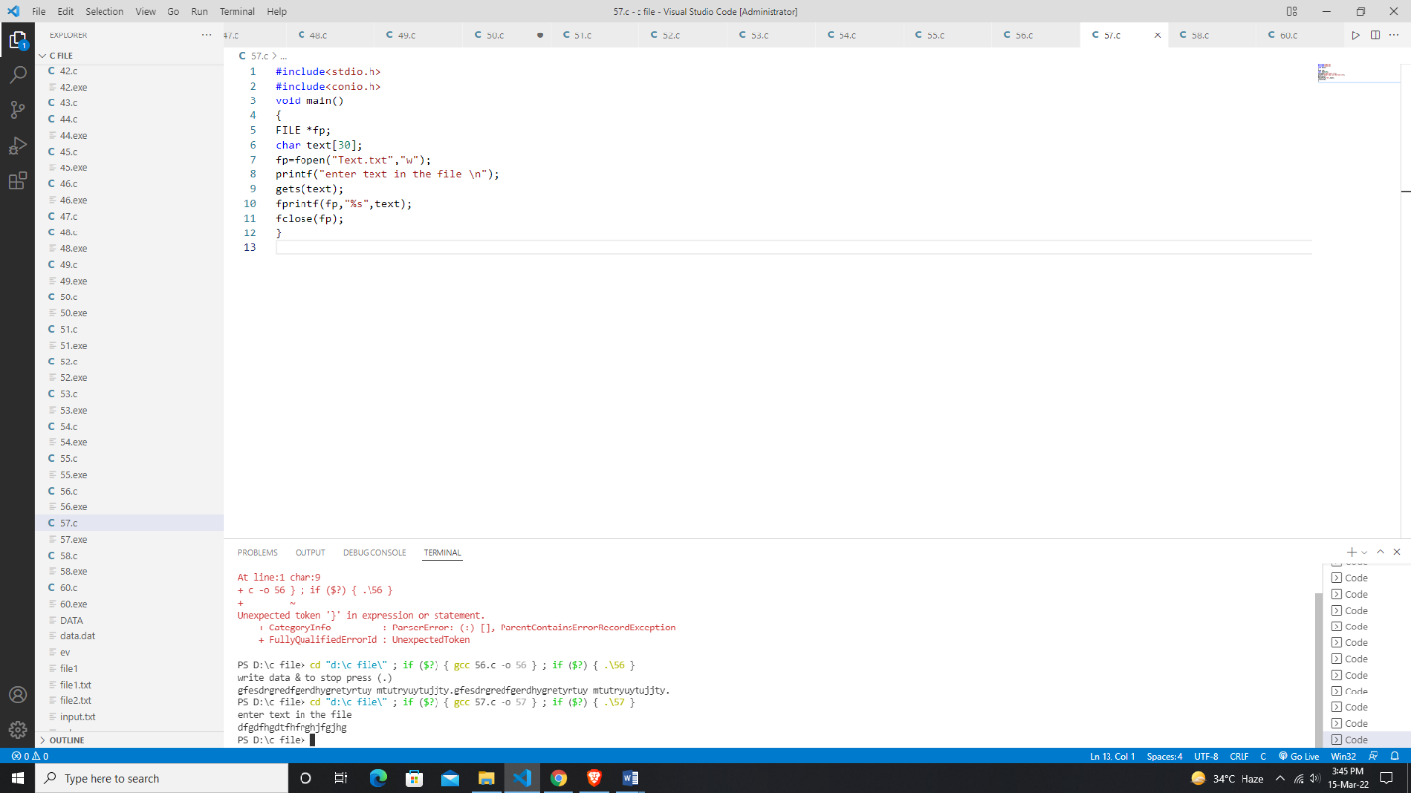

***Program 58: Write a program to create a file data which contains a series of integer numbers and write all the odd numbers to a file called odd file and all even numbers in even file.***

#include <stdio.h>

#include <conio.h>

void main()

{

    FILE*f1,*f2,*f3;

    int i, j;

    printf("Enter the data \n");

    f1=fopen("file1", "w");

    for(i=0;i<=10;i++)

    {

        scanf("%d",&j);

        if(j==-1)break;

        putw(j,f1);

    }

    fclose(f1);

    f1=fopen("file1","r");

    f2=fopen("od","w");

    f3=fopen("ev","w");

    while((j=getw(f1))!=EOF)

    {

        if(j%2==0)

        putw(j,f3);

        else

        putw(j,f2);

    }

    fclose(f1);

    f1=fopen("file1","r");

    f2=fopen("od","w");

    f3=fopen("ev","w");

    while((j=getw(f1))!=EOF)

    {

        if(j%2==0)

        putw(j,f3);

        else

        putw(j,f2);

    }

    fclose(f1);

    fclose(f2);

    fclose(f3);

    f2=fopen("od","r");

    f3=fopen("ev","r");

    printf("Contents of ODD File \n");

    while((j=getw(f2))!=EOF)

    printf("%4d \n",j);

    printf("Contents of EVEN File \n");

    while((j=getw(f3))!=EOF)

    printf("%4d \n",j);

    fclose(f2);

    fclose(f3);

    getch();

}

Output:

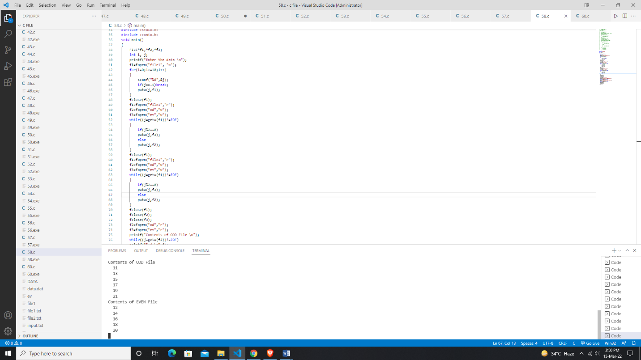

***Program 59:***

***Program 60: Write a program to read the text file containing some sentence use fseek() function and read the text after skipping n characters from beginning of the file.***